Final Hands-On Assessment: Completed Documentation
Samara Vargas Linares

Valencia College
202630 Administering Windows Server CET-2793C-32156

Table of Contents
Diagram Section: 2
Network Diagram 2
ADDS Diagram 3
Shared Folder Diagram 4
Build Section: 5
Initial Build Screenshots 5
Server # 1 Screenshots 5
OU Screenshots 5
Server #2 Screenshots [including DHCP] 5
Client Screenshots 5
Server #3 Screenshots 5
Shared Folder Screenshots 5
GPO Screenshots 5
Windows Admin Center Screenshots 5

Diagram Section:

Network Diagram
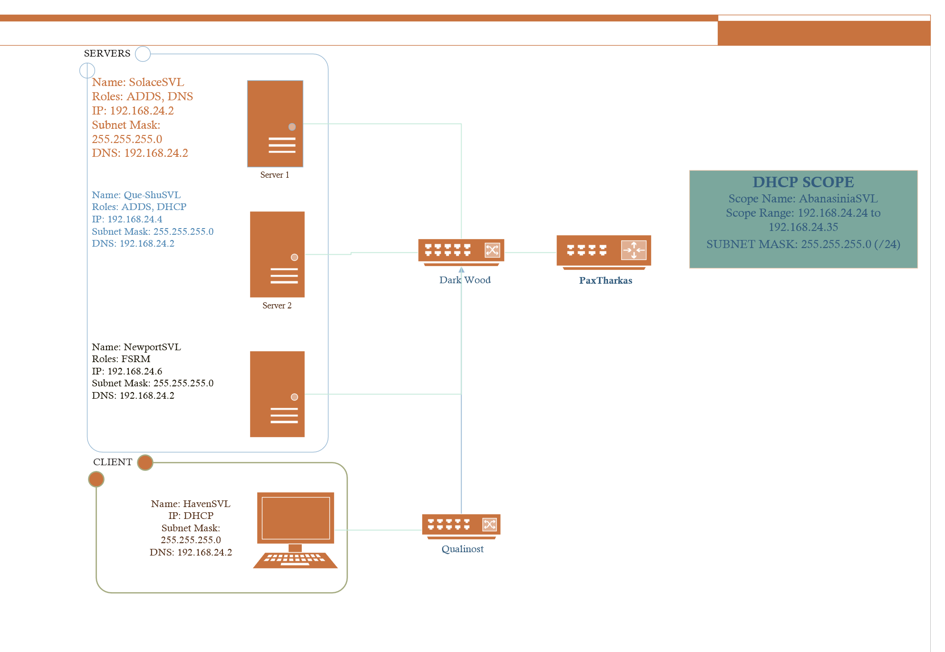
Figure 1 Network Diagram for the domain Inn Of The Last Home

ADDS Diagram
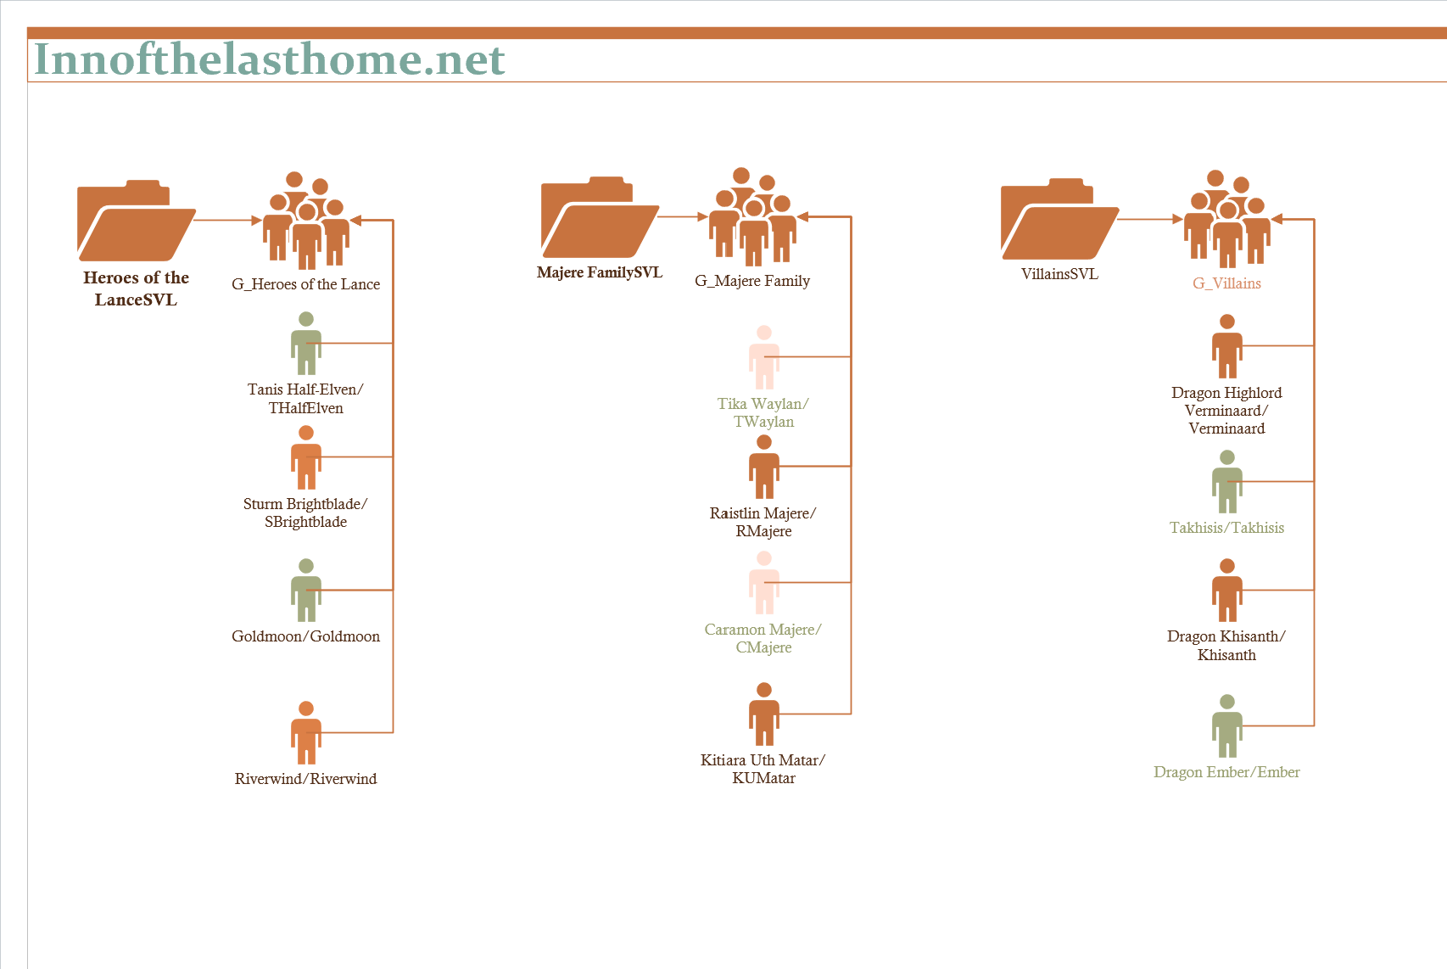
Figure 2 ADDS Diagram for the domain Inn Of The Last Home

Shared Folder Diagram
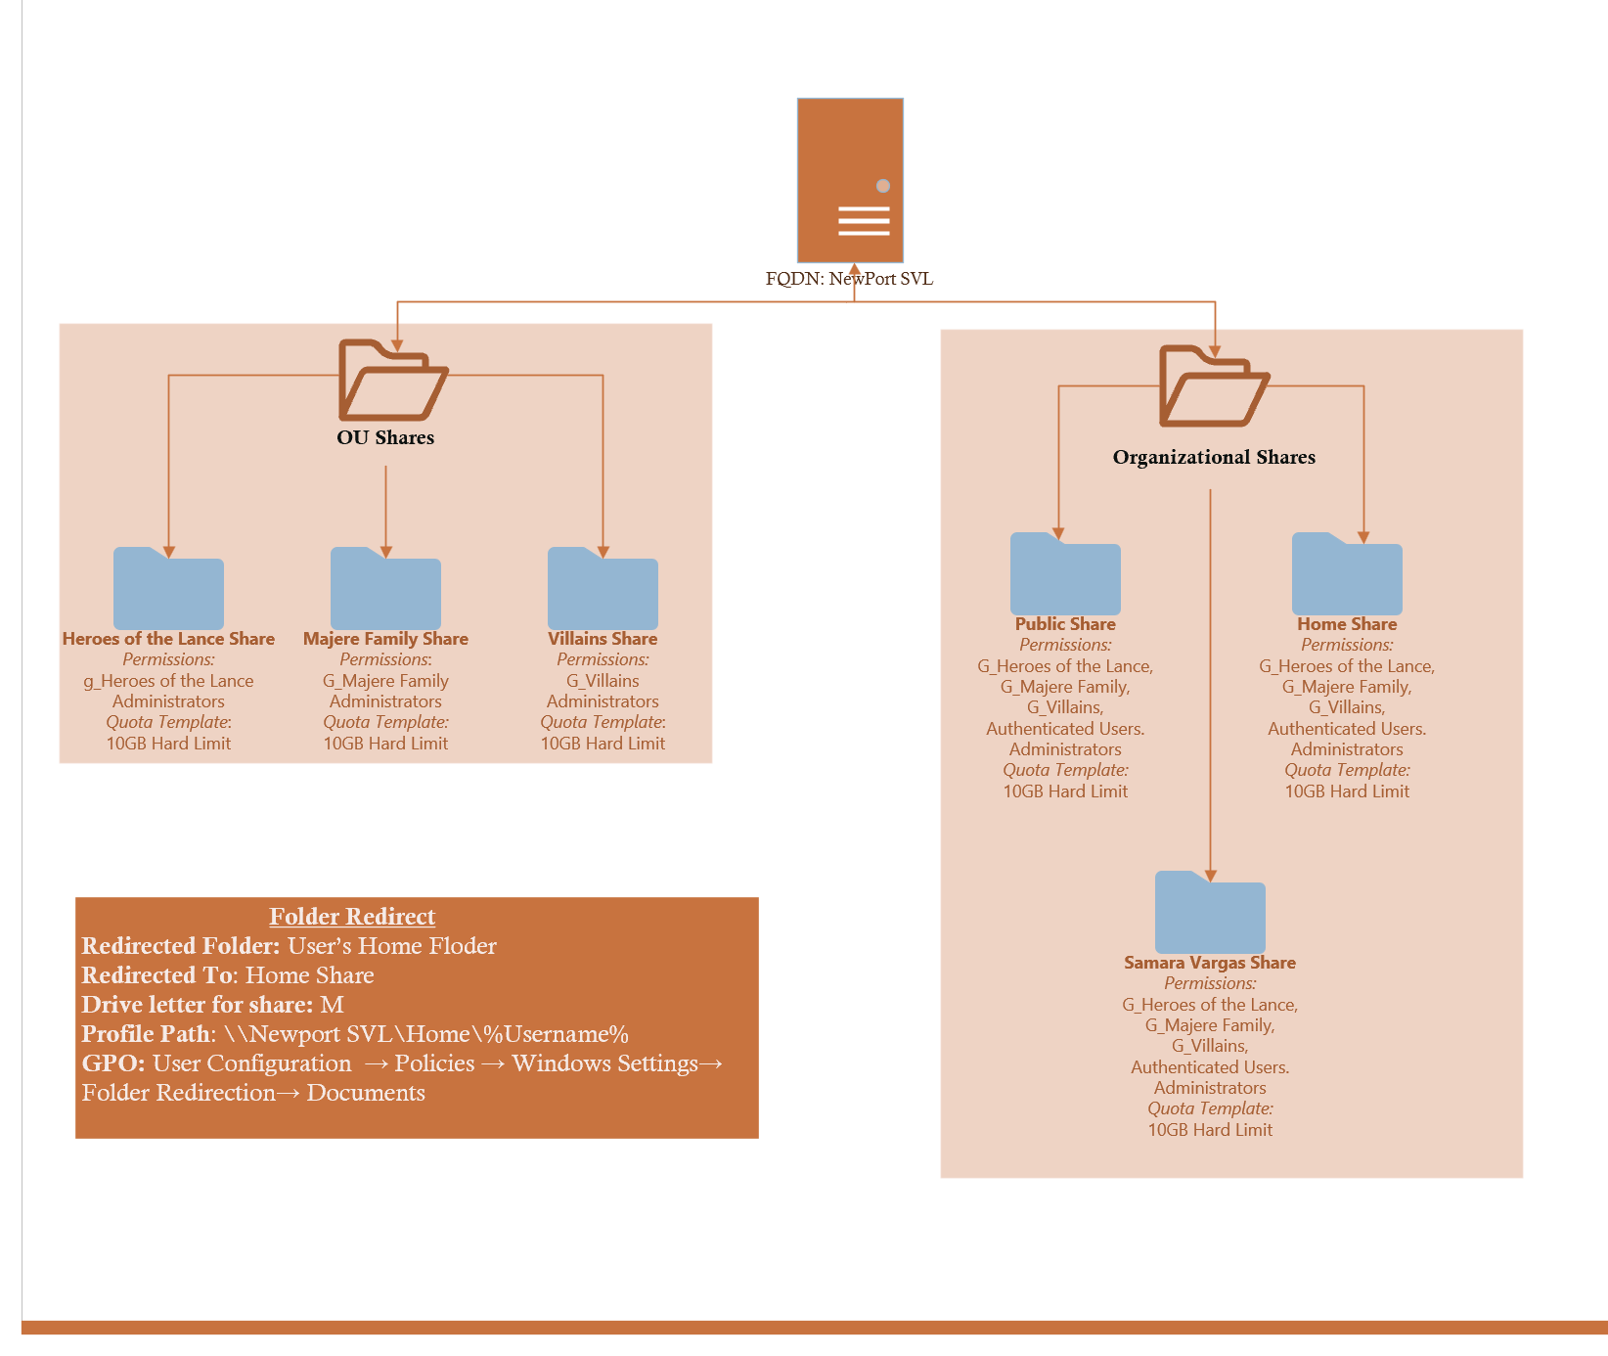
Figure 3 Shared Folder Diagram for the domain Inn Of The Last Home

Build Section:

Initial Build
Server1
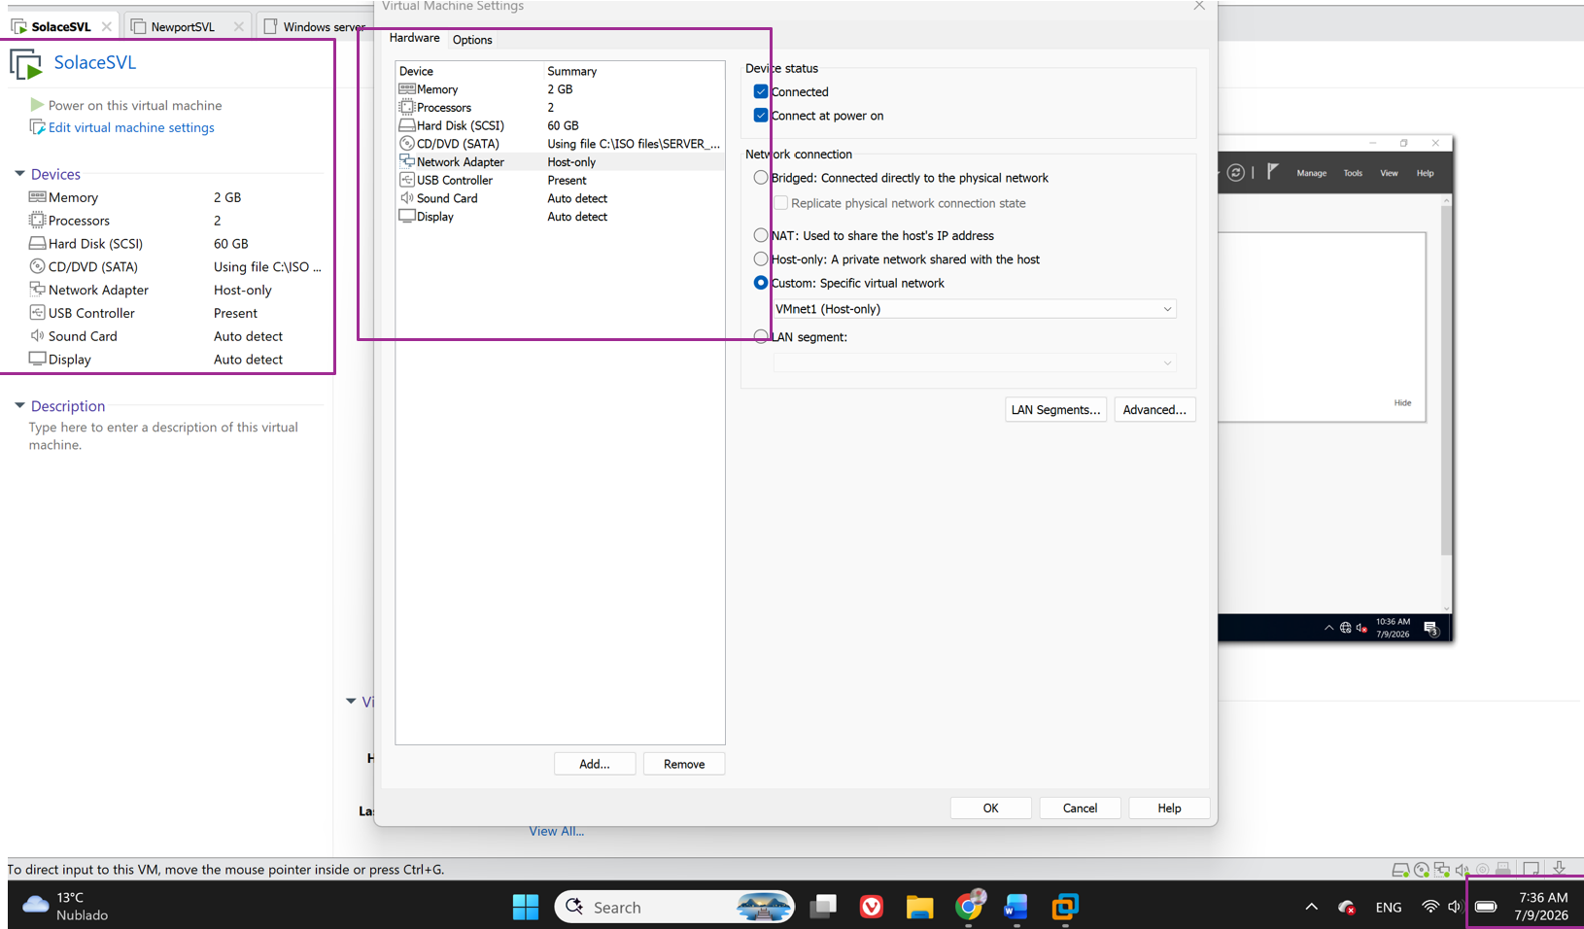
Figure 4 VMware Hardware Settings For server 1
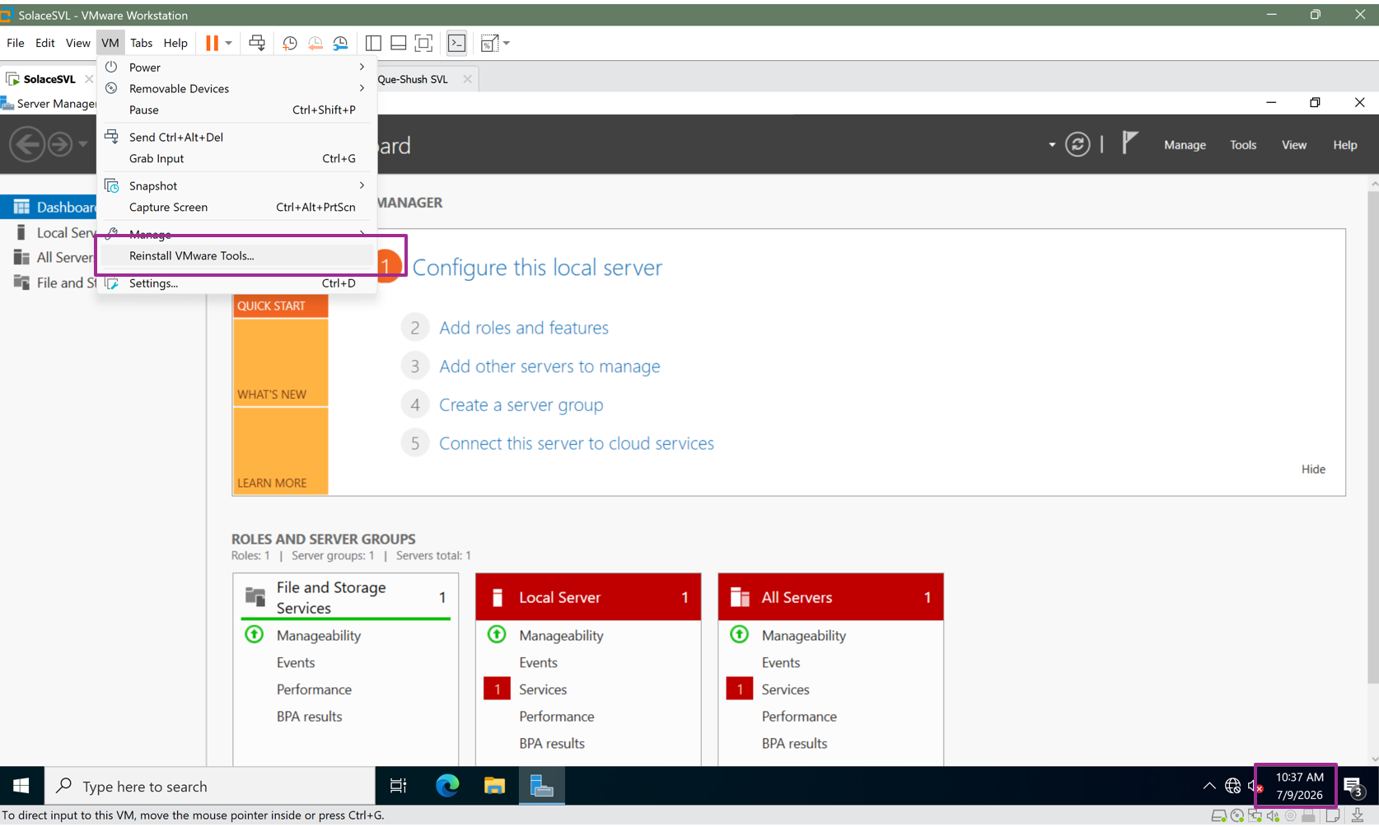Figure 5 VMware Tools Installed on server 1

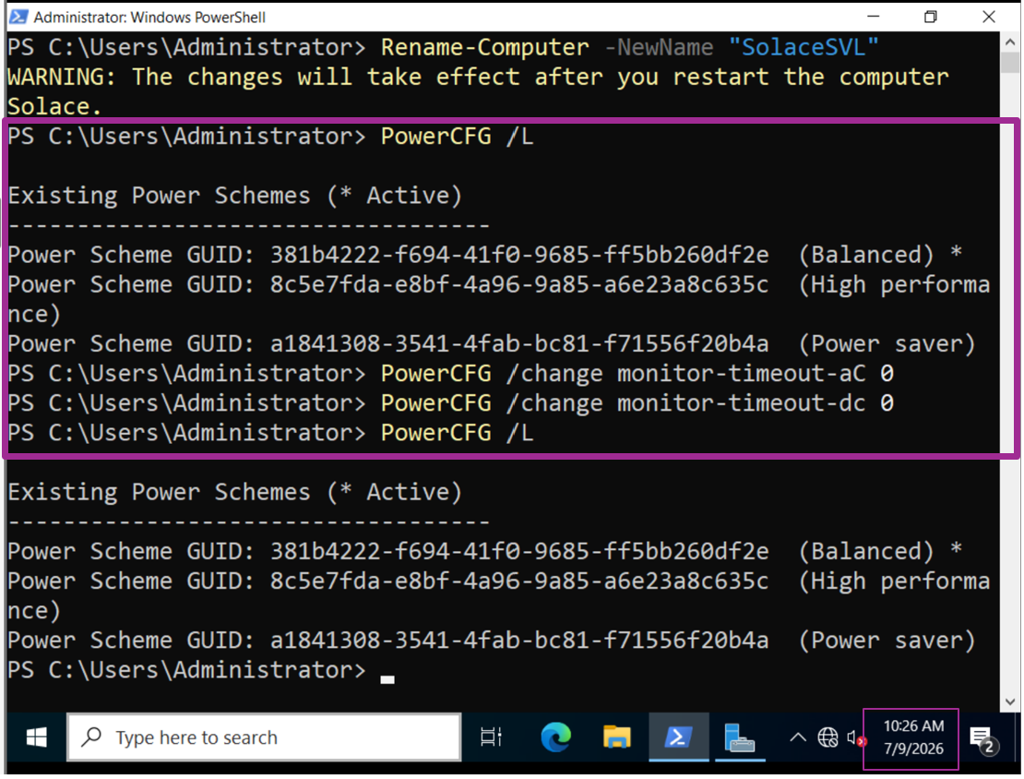
Figure 6 Server 1 Power CFG output

Server 2
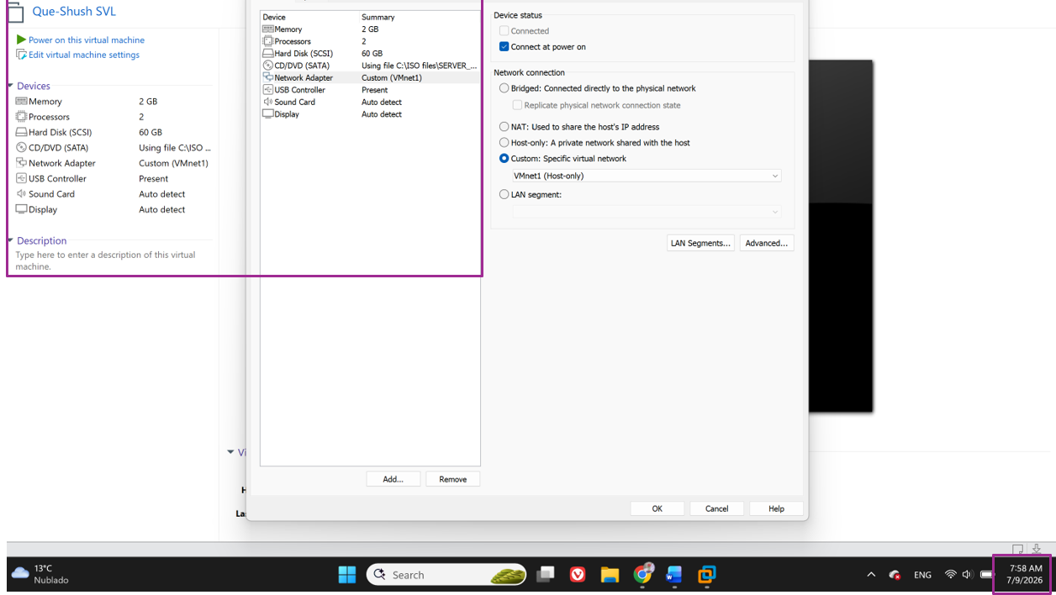
Figure 7 vmware Hardware Settings for server 2
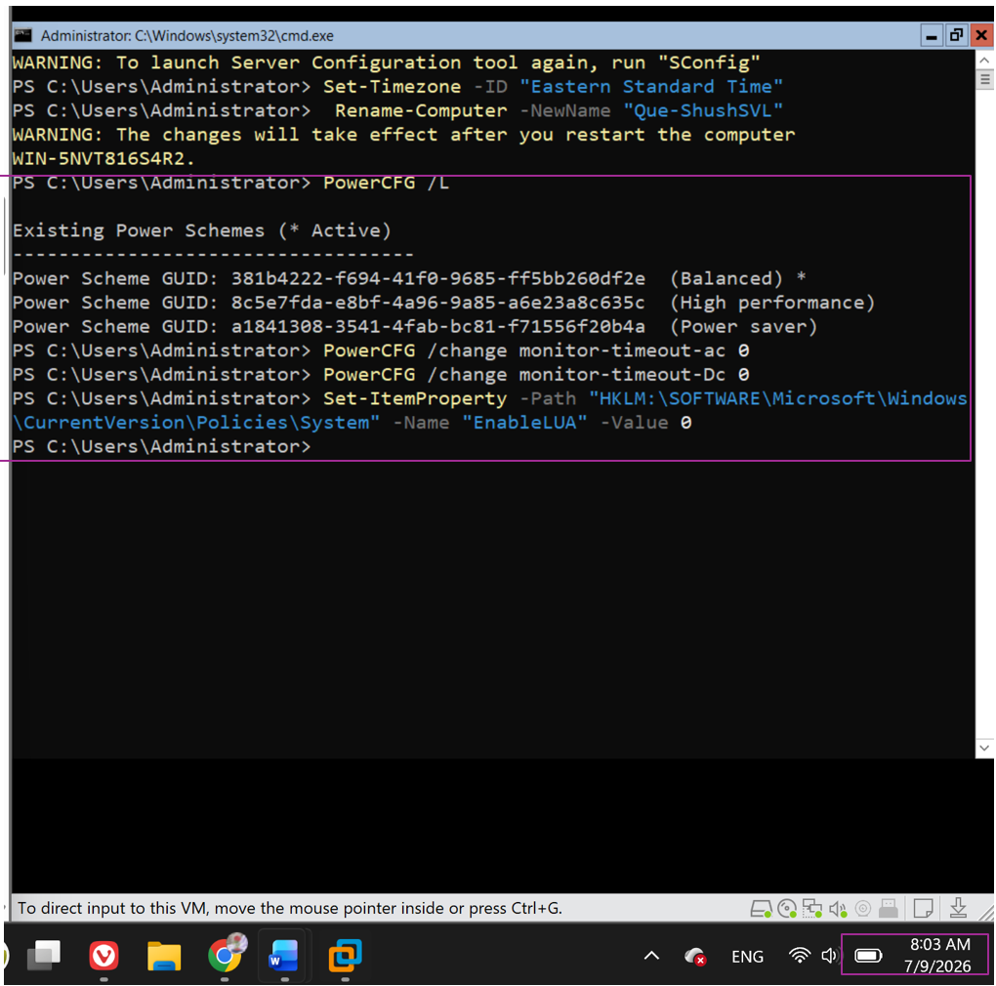Figure 8 PowerCFG output for server 2

Server 3:
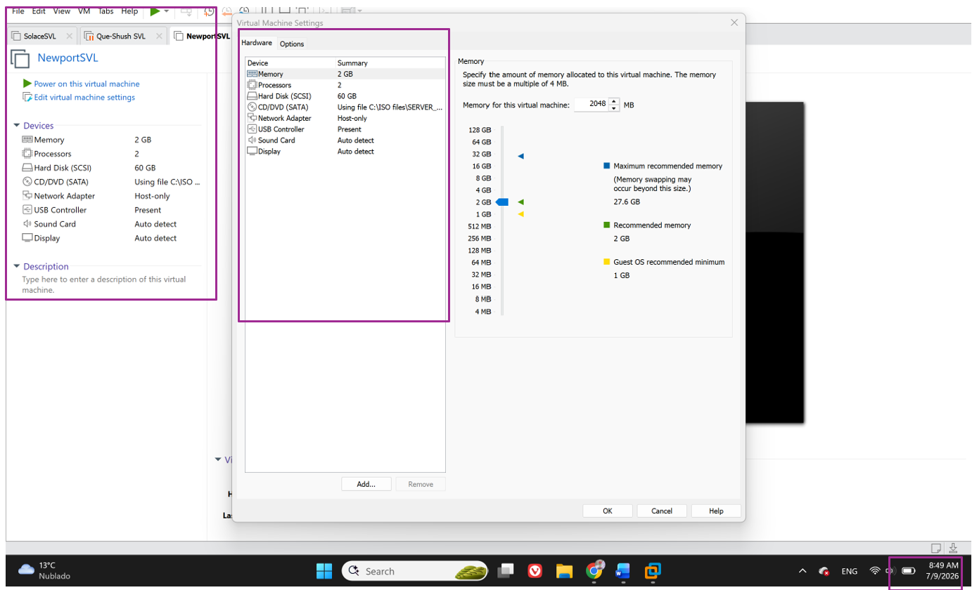
Figure 9 VMware Hardware Settings for server 3
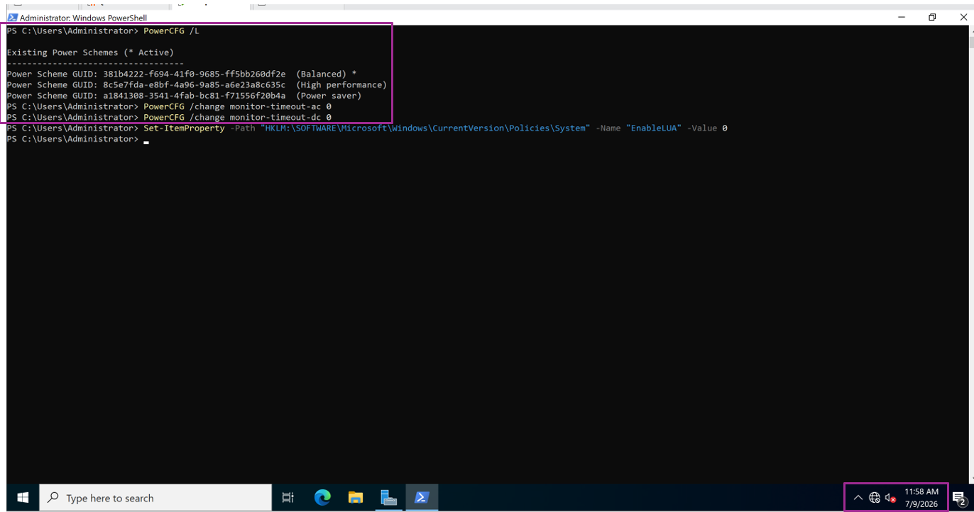Figure 10 PowerCFG Output for server 3

Server # 1 Domain Controller
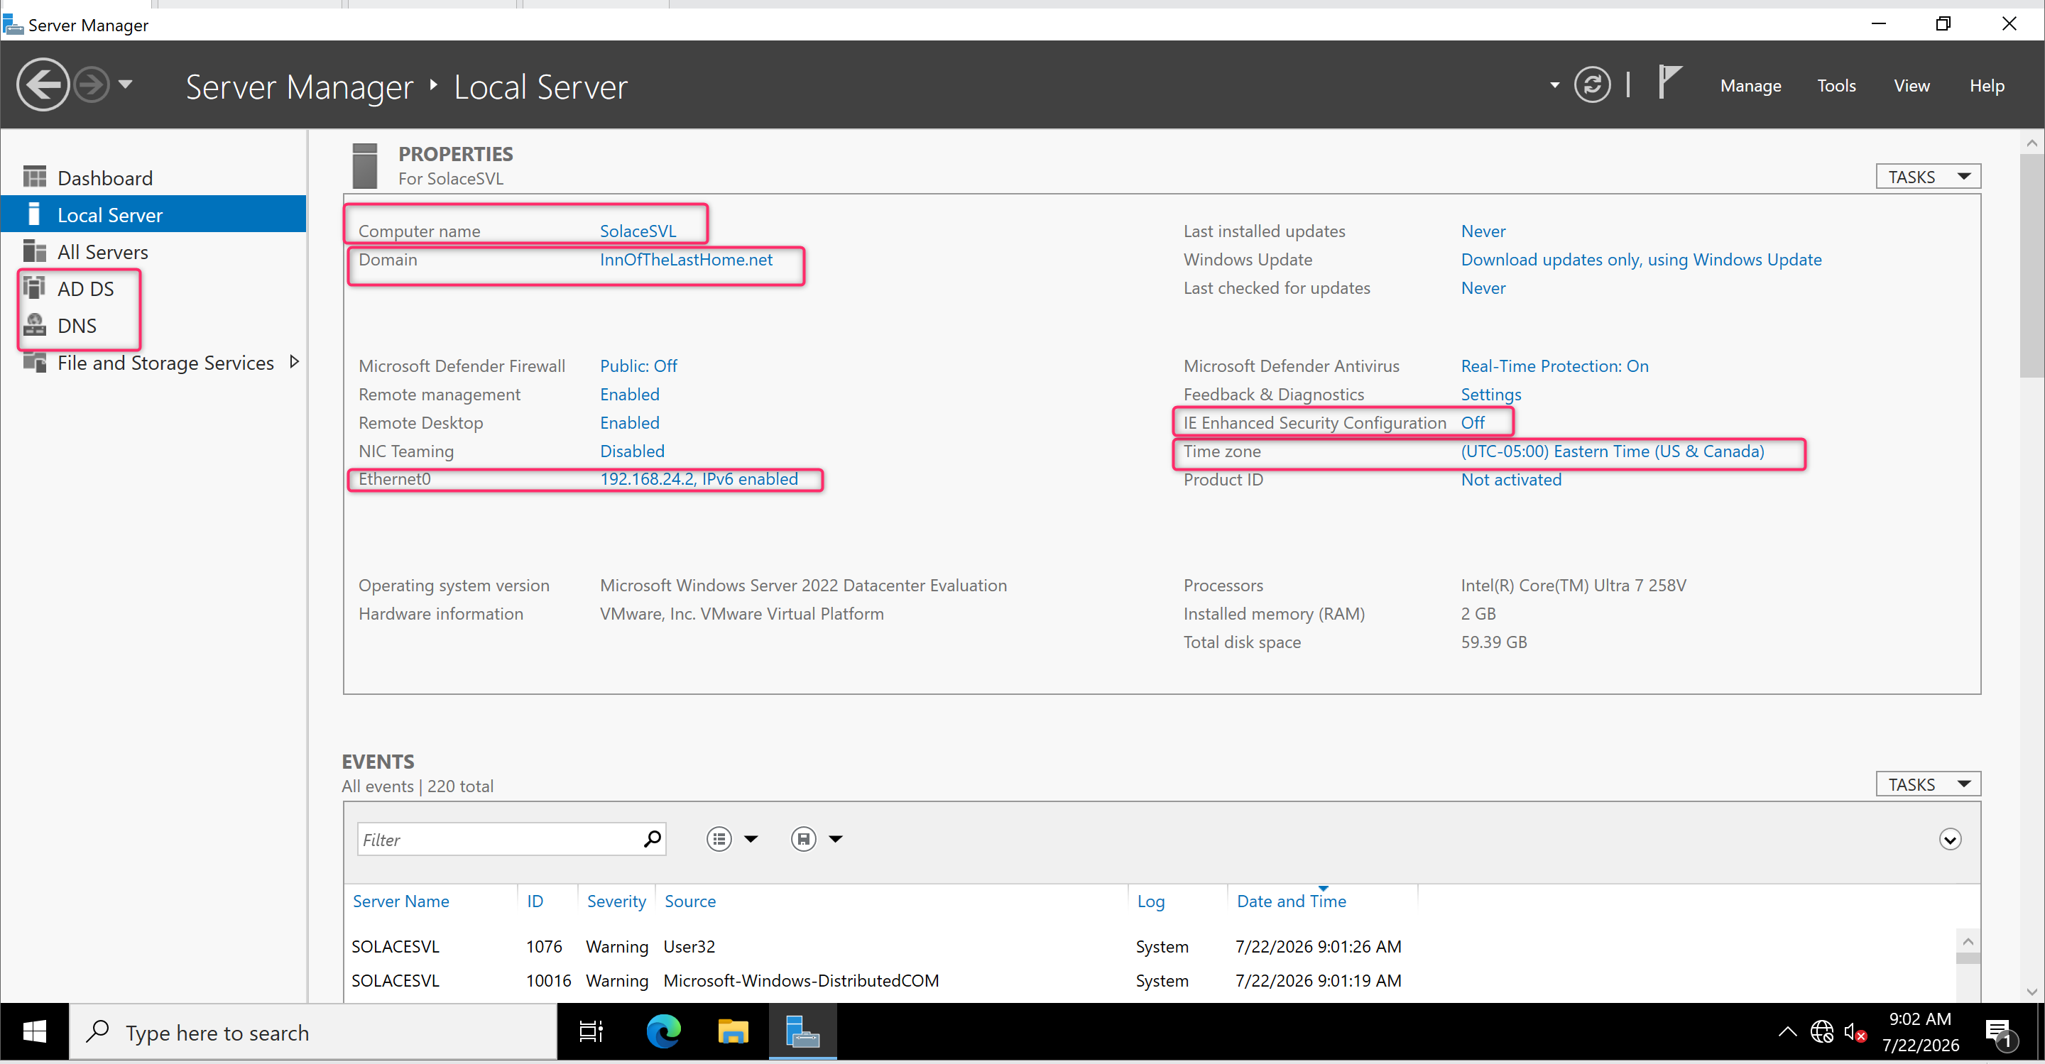Figure 11 Server #1 (Domain Controller) Server Manager, Local Server information

OU Screenshots
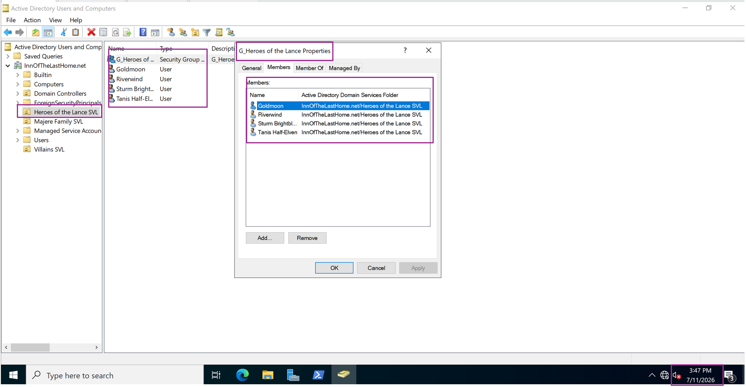
Figure 12 Heroes of the lance Users in their group and OU

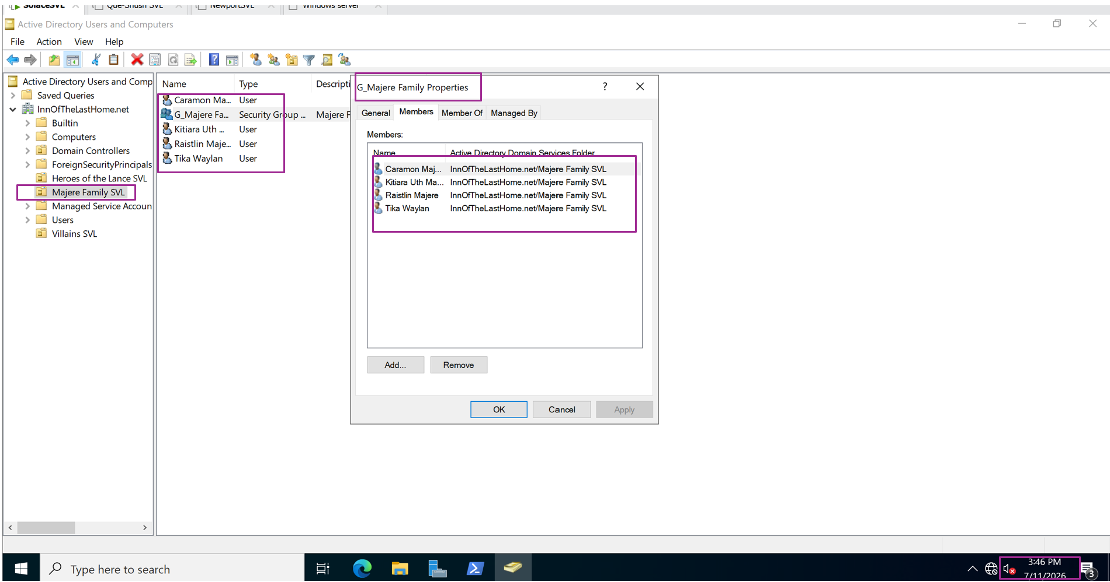
Figure 13 Majere Family Users in their group and OU
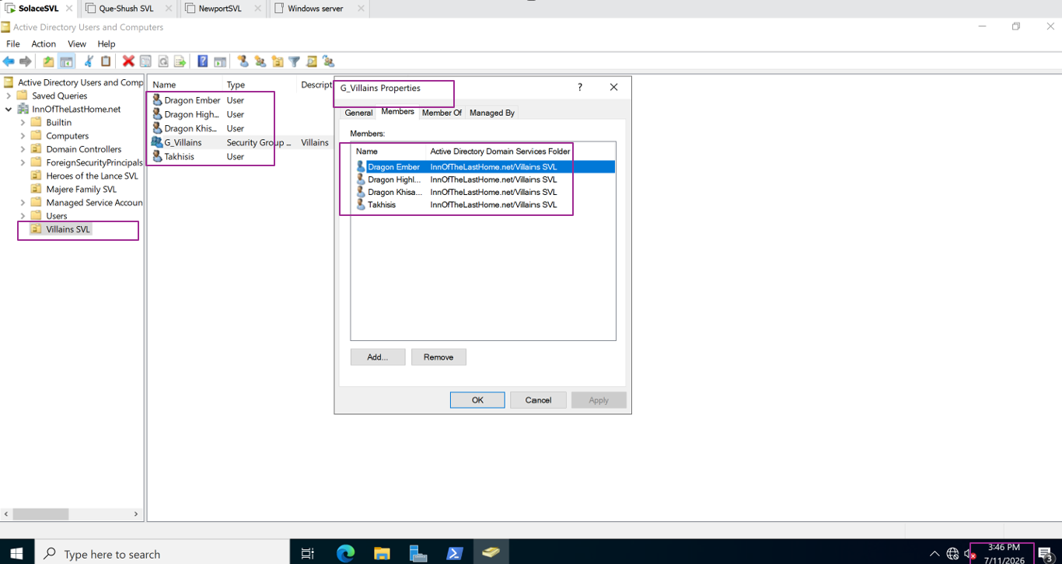
Figure 14 Villains Users in their group and OU
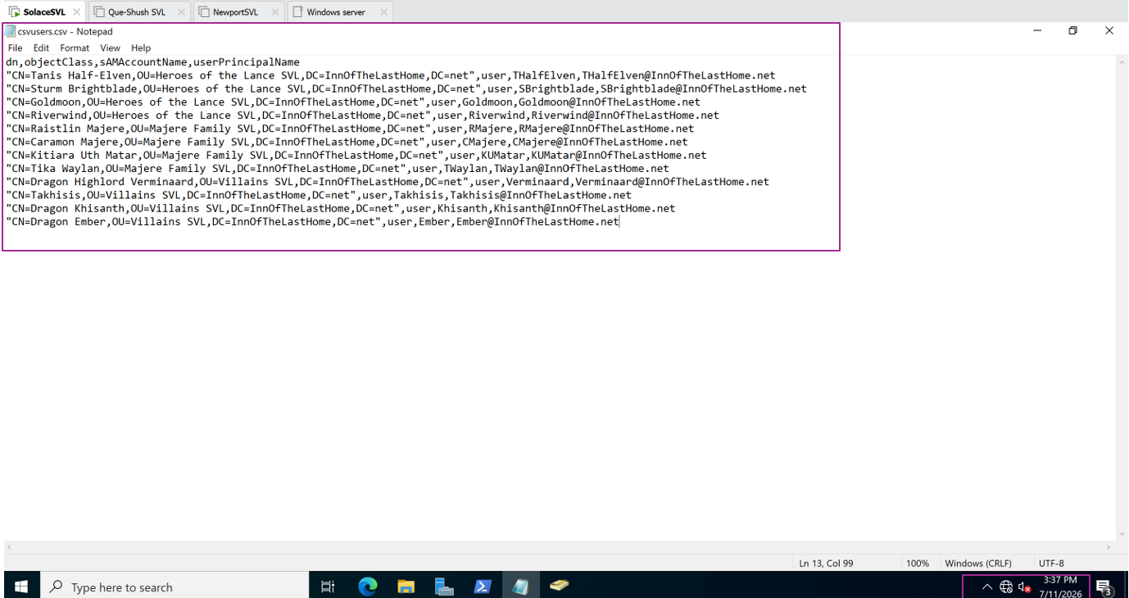
Figure 15 CSV file
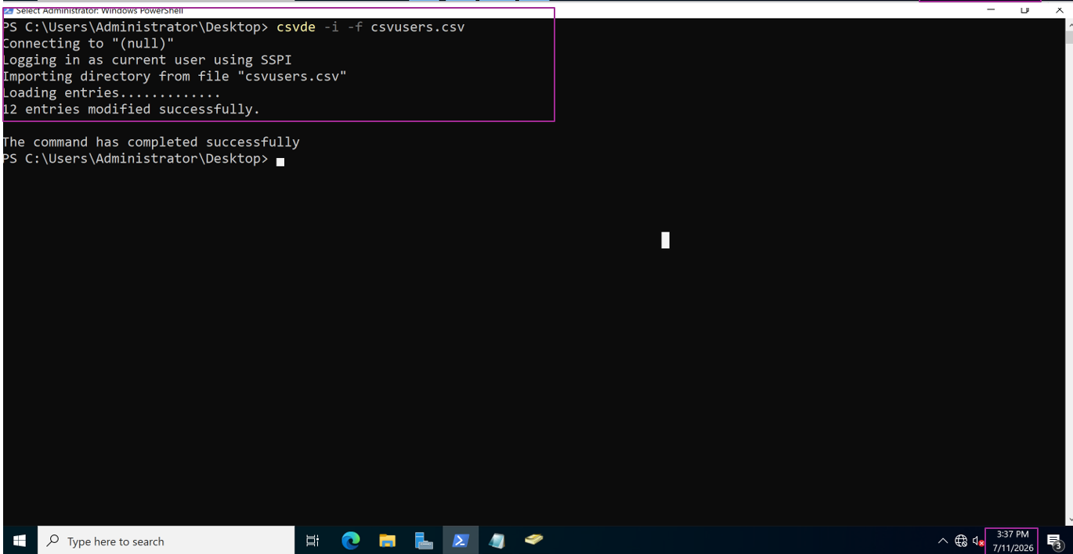Figure 16 Import Command

Server #2 (DHCP)
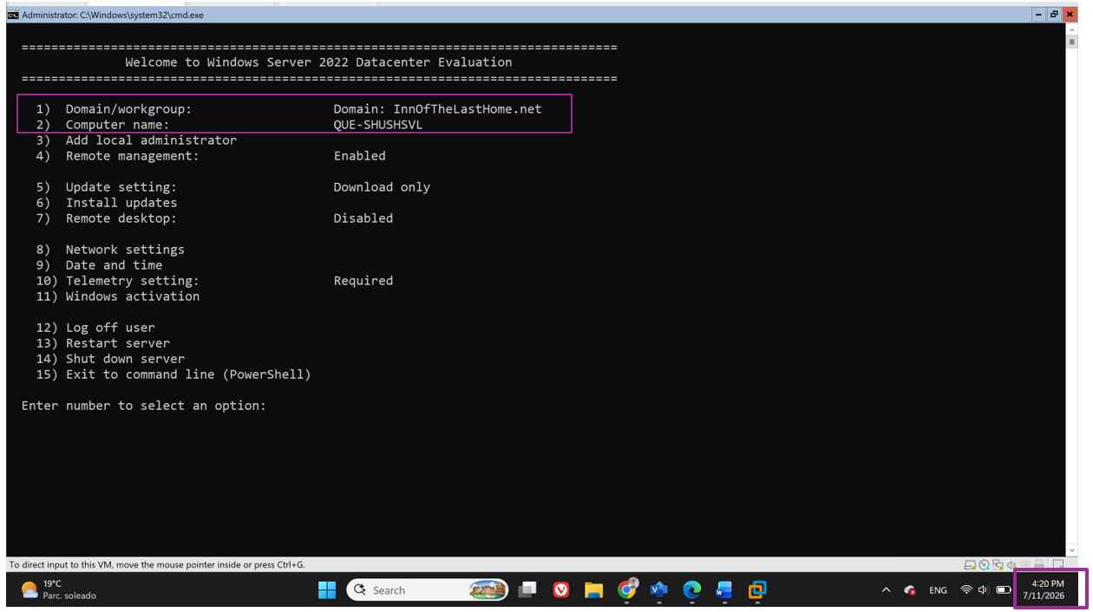
Figure 17 Server 2 Sconfig Showing the domain and the name of the server
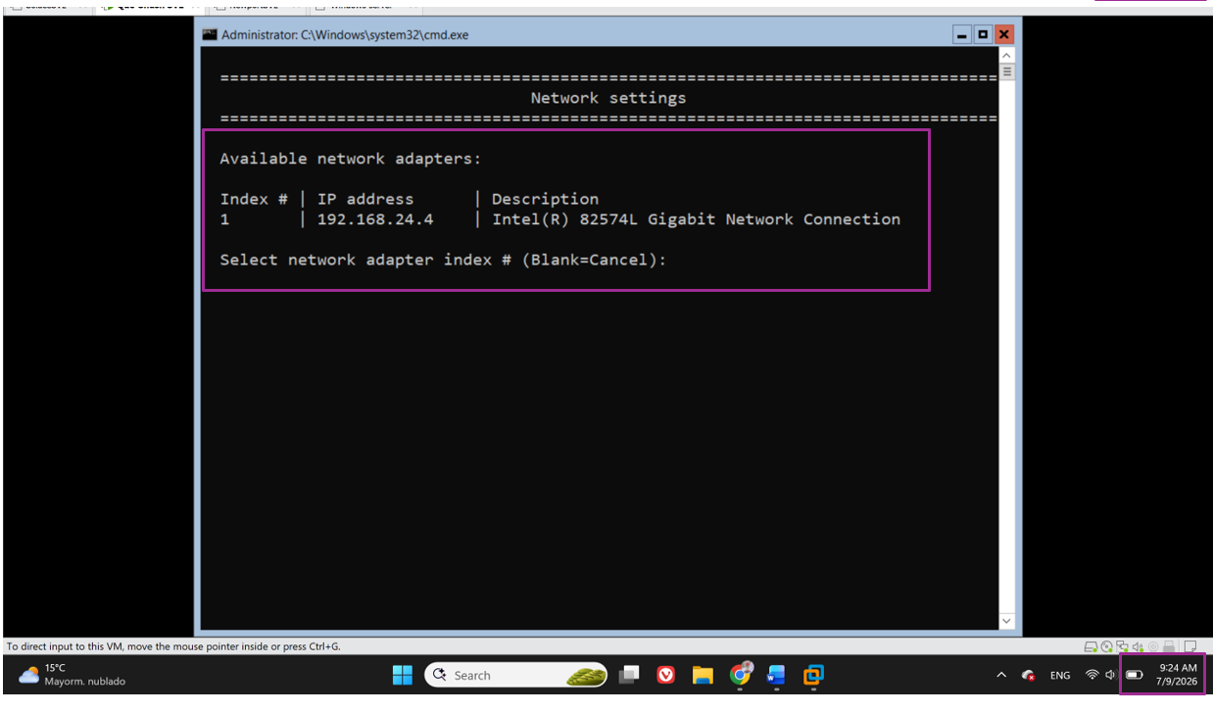Figure 18 Sconfig output showing the ip address of server 2
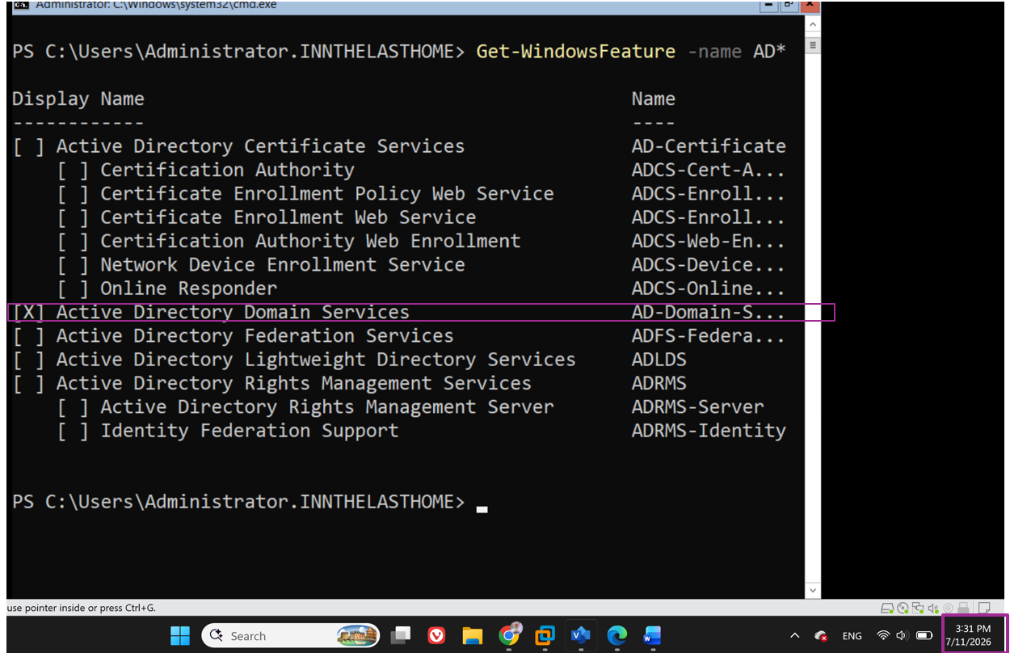
Figure 19 Screenshot showing ADDS is installed
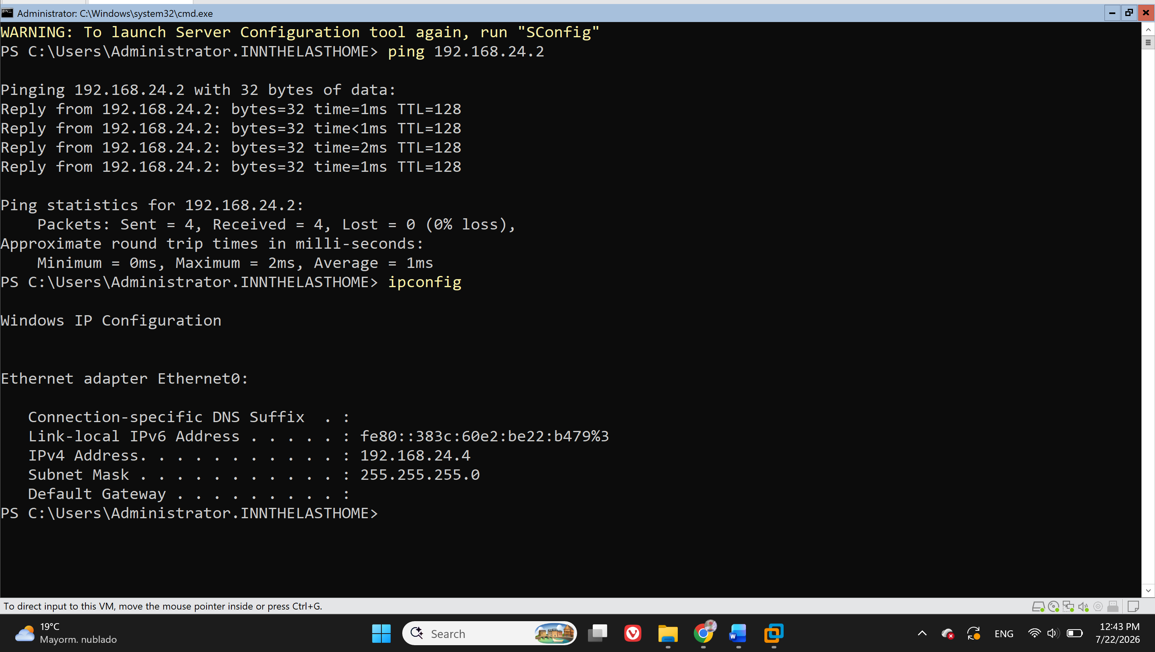
Figure 20 Ping between servers
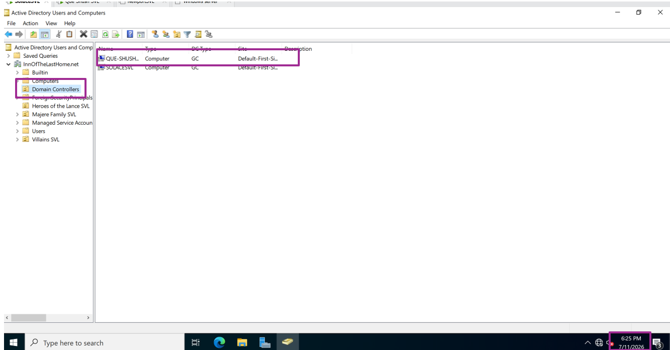
Figure 21 Second Server Shown as DC in ADUC
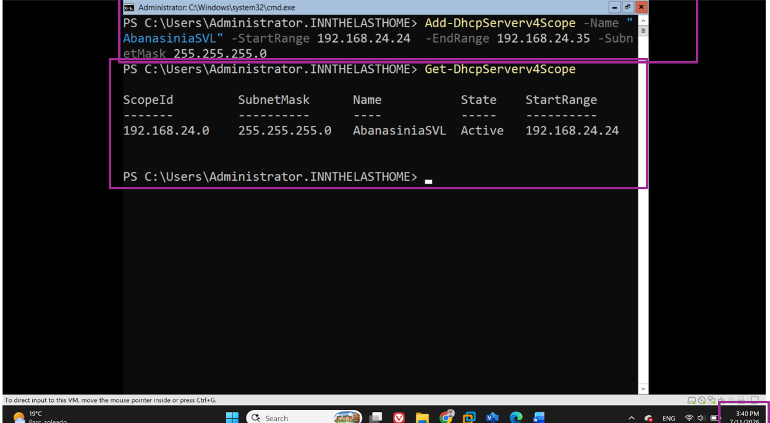
Figure 22 DHCP Scope

Client Machine
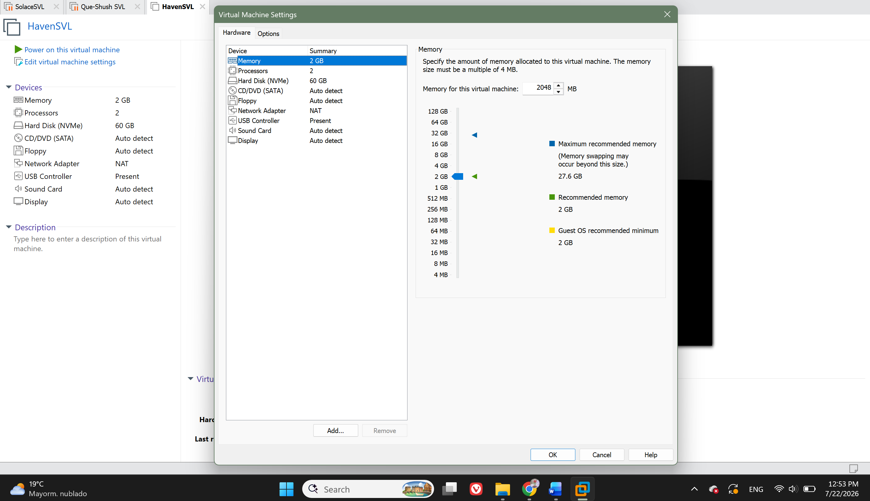Figure 23 Client Machine VM Hardware Settings
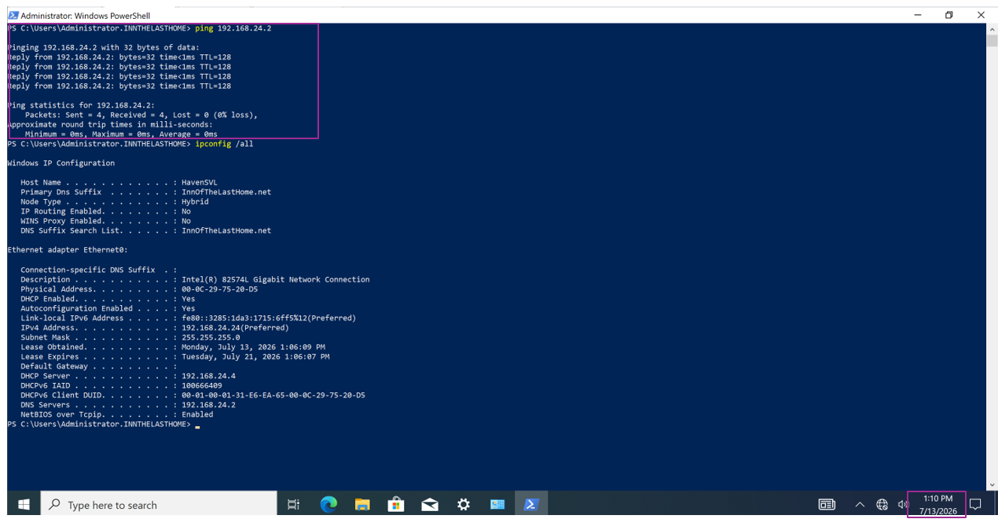Figure 24 Ping from client machine to Server 1
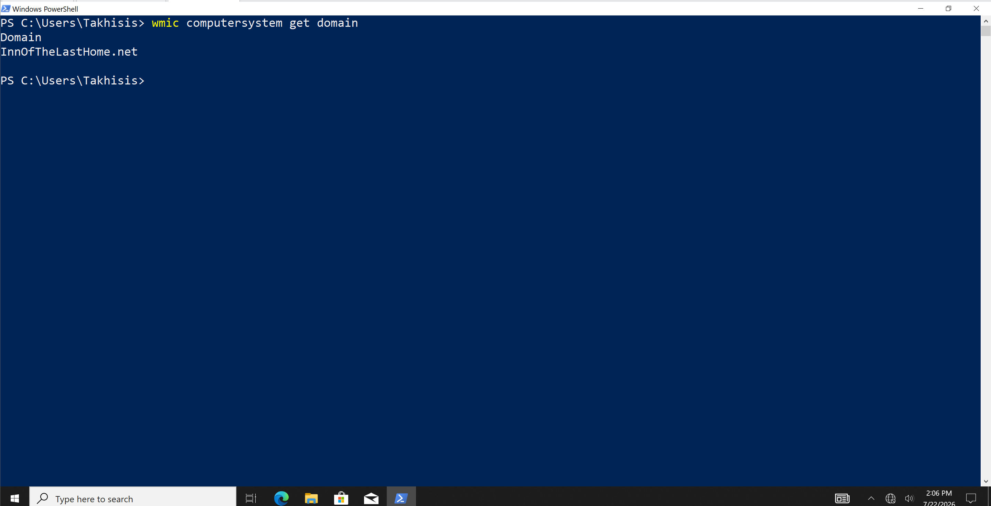Figure 25 Client Joined to the domain
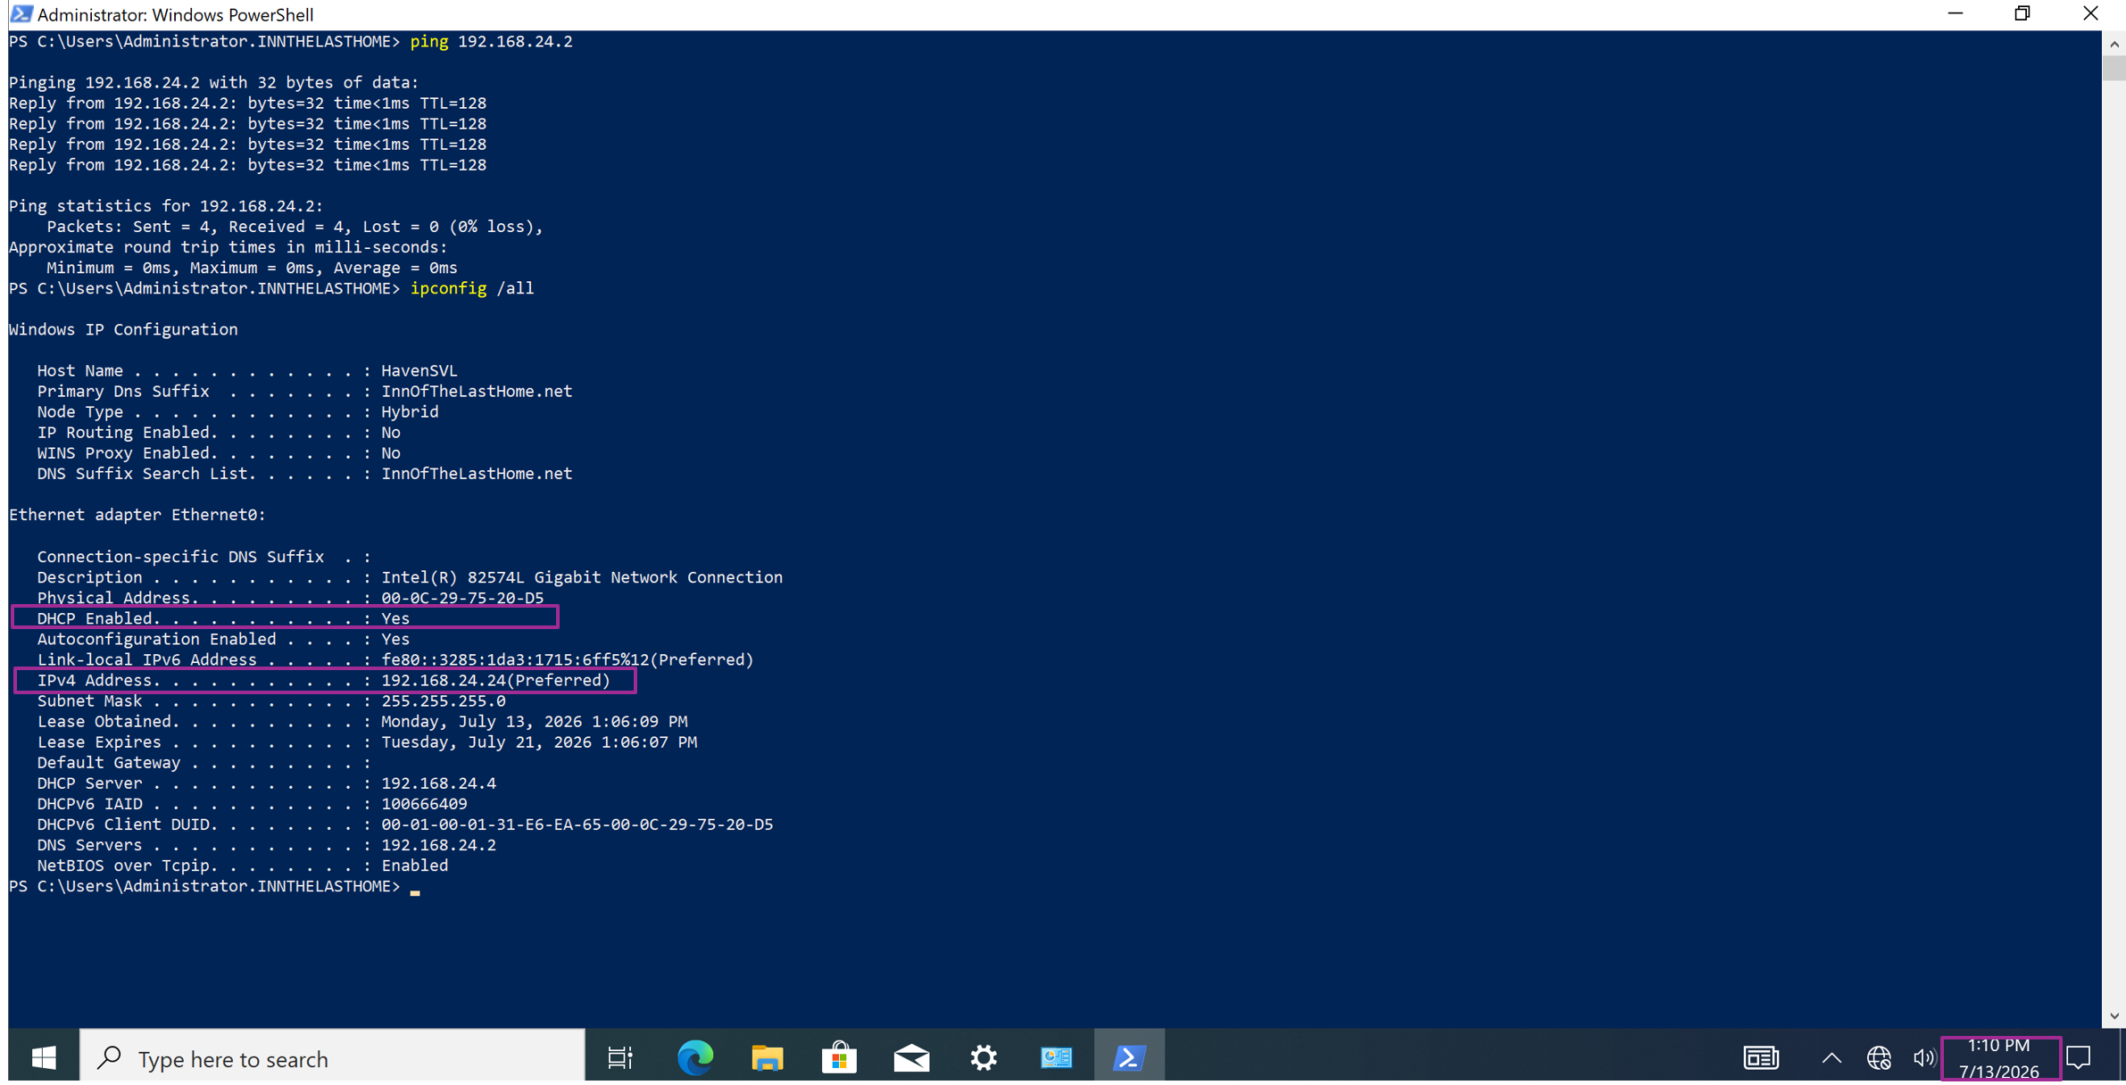Figure 26 DHCP client

Server #3 Screenshots
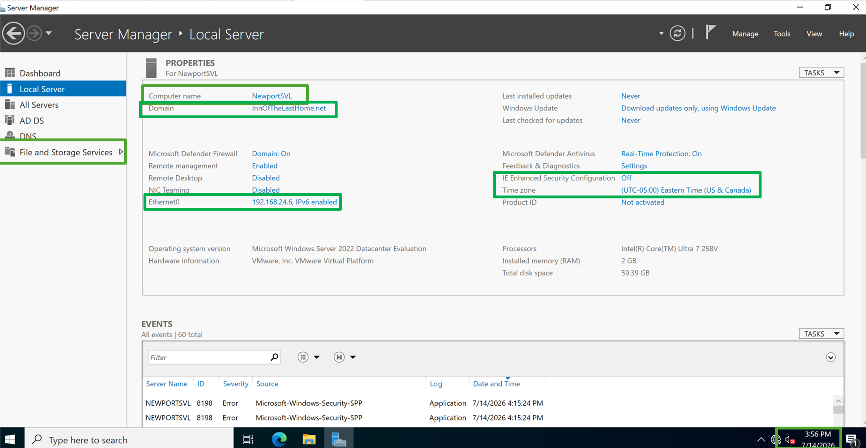Figure 27 Local Server information showing the File server is configured and has FSRM installed

Shared Folder Screenshots
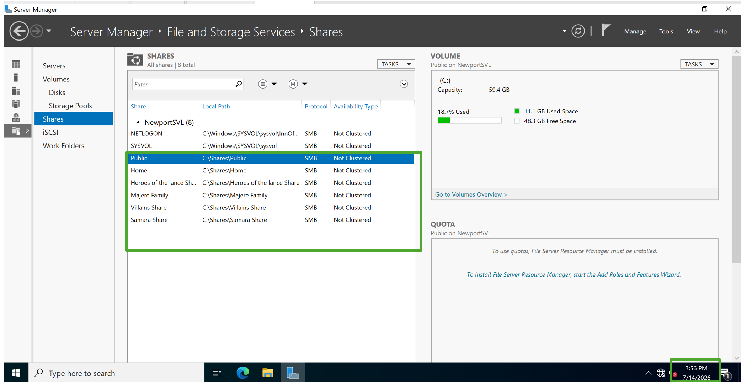Figure 28 The list of folders on the file server permissions info
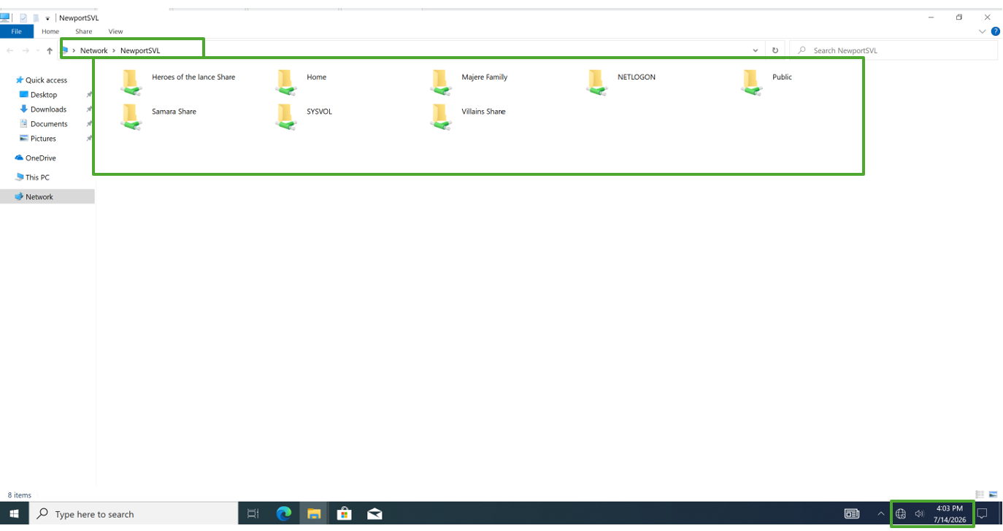
Figure 29 The list of folders on the Client Machine
Figure 30 The document you created on the client, on the file server

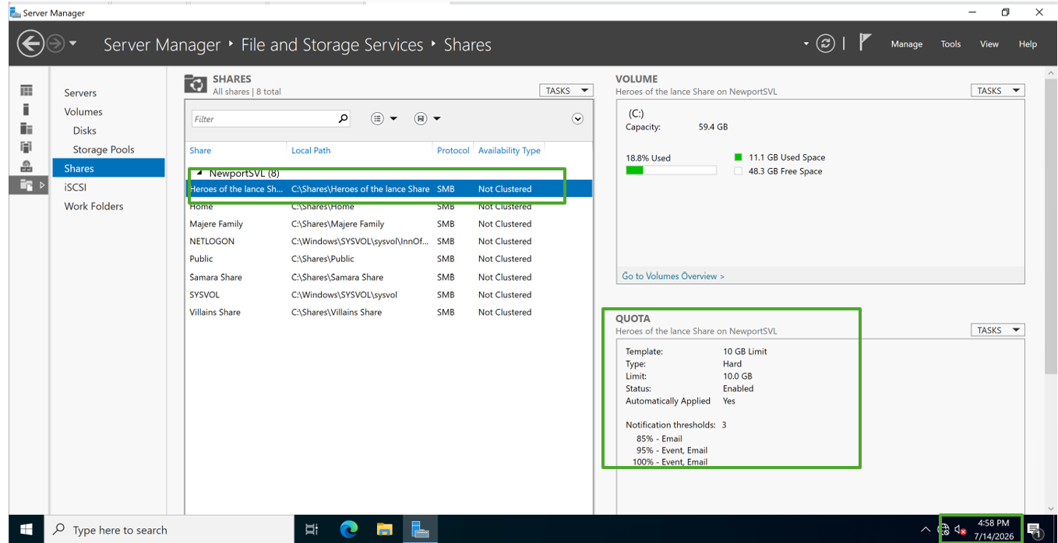
Figure 31 Heroes of the lance folder Quota
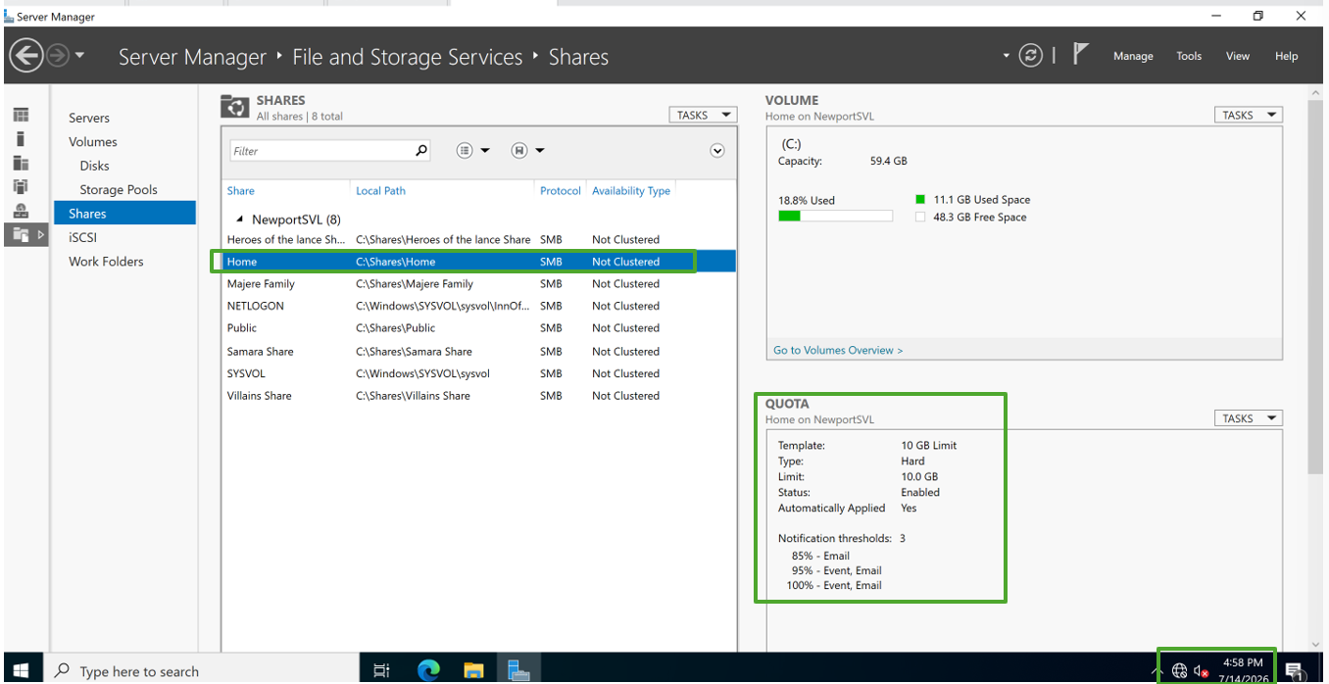
Figure 32 Home folder Quota
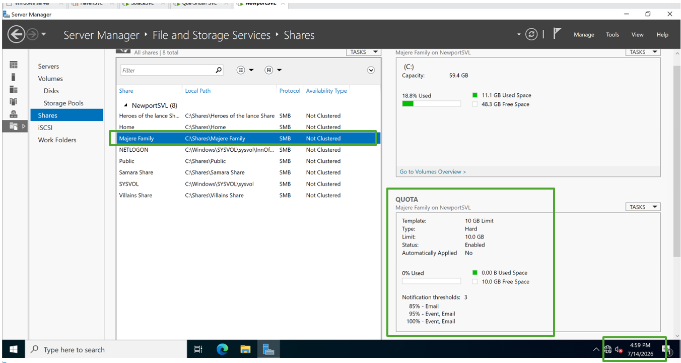
Figure 33 Majere Family folder Quota
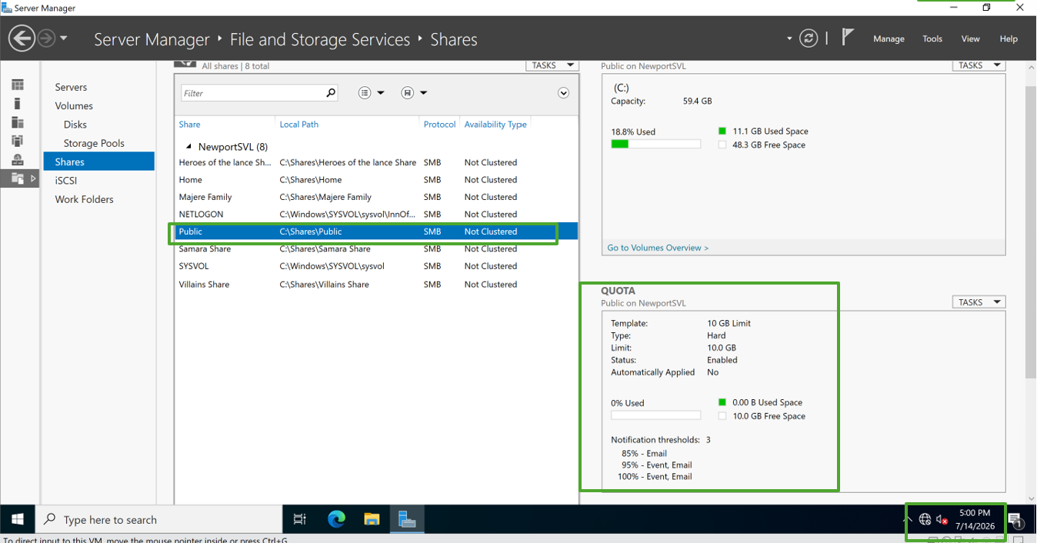
Figure 34 Public folder Quota
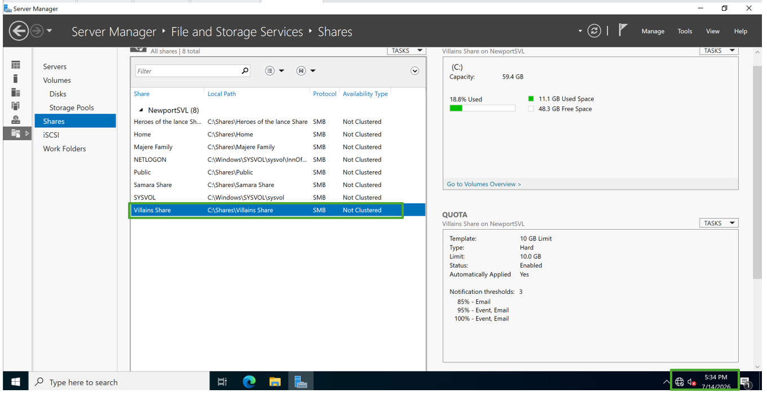
Figure 35 Villians Share folder Quota
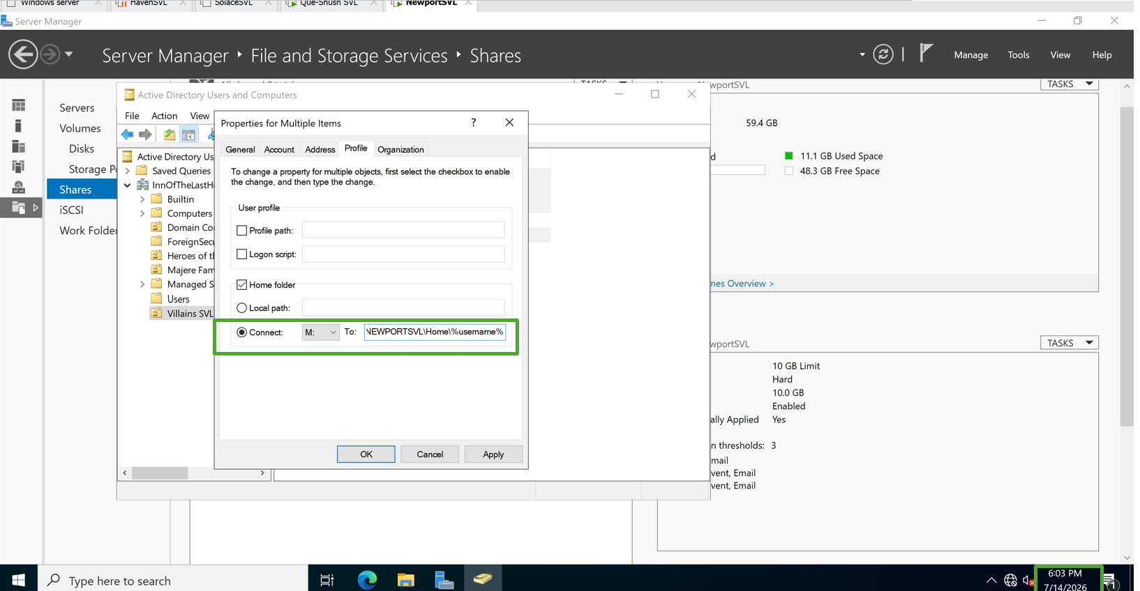Figure 36 Profile settings showing the drive letter AND the path for the shared folder
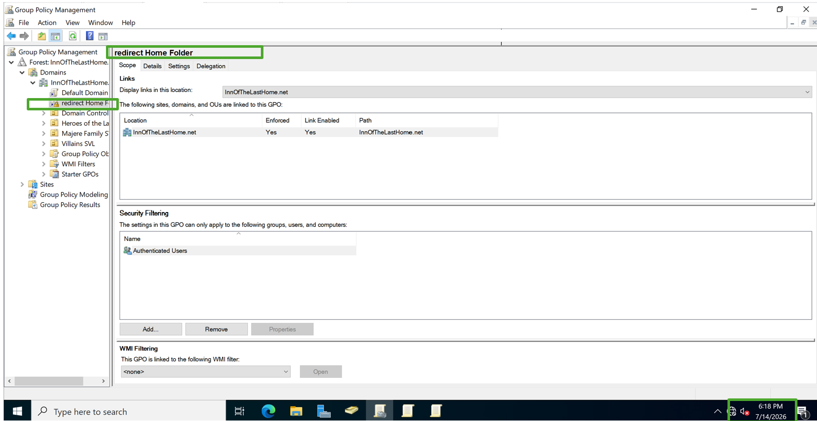Figure 37 GPO setting
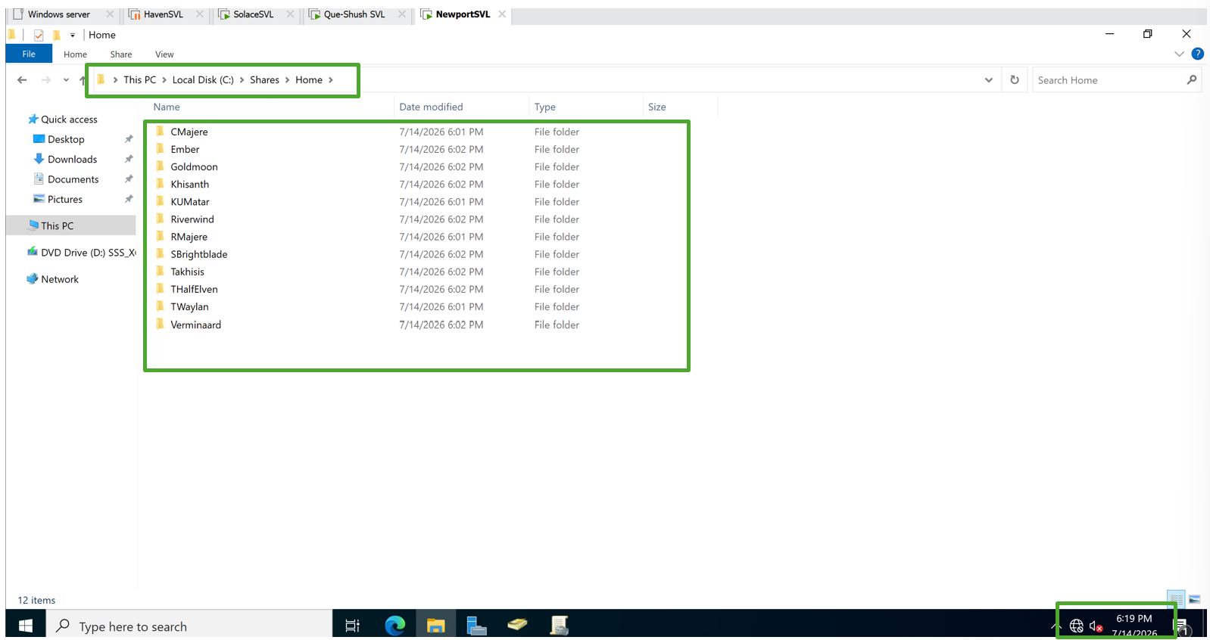Figure 38 folders in the Shares area of the File ServER

Group Policy Objects
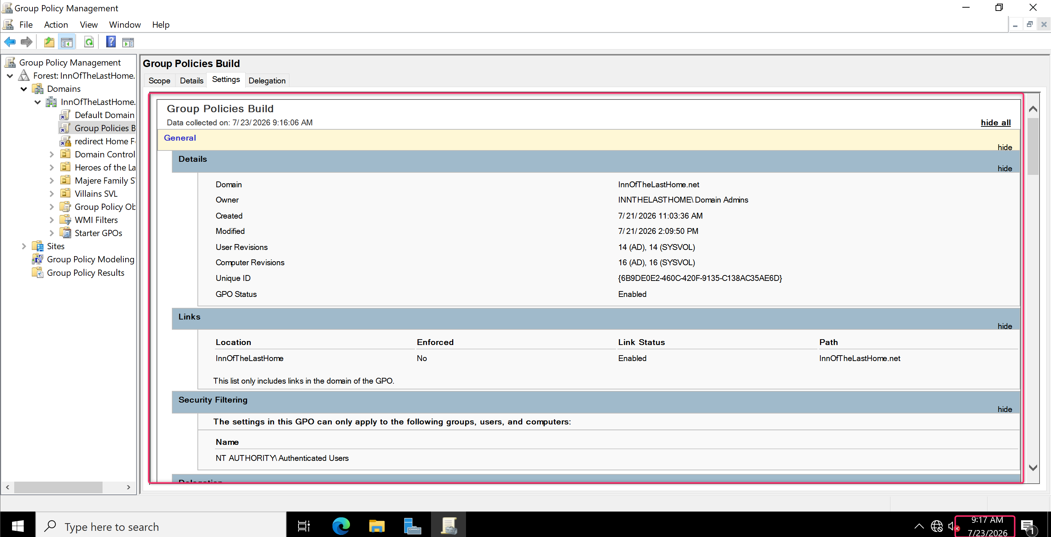
Figure 39 Group Policy Objects
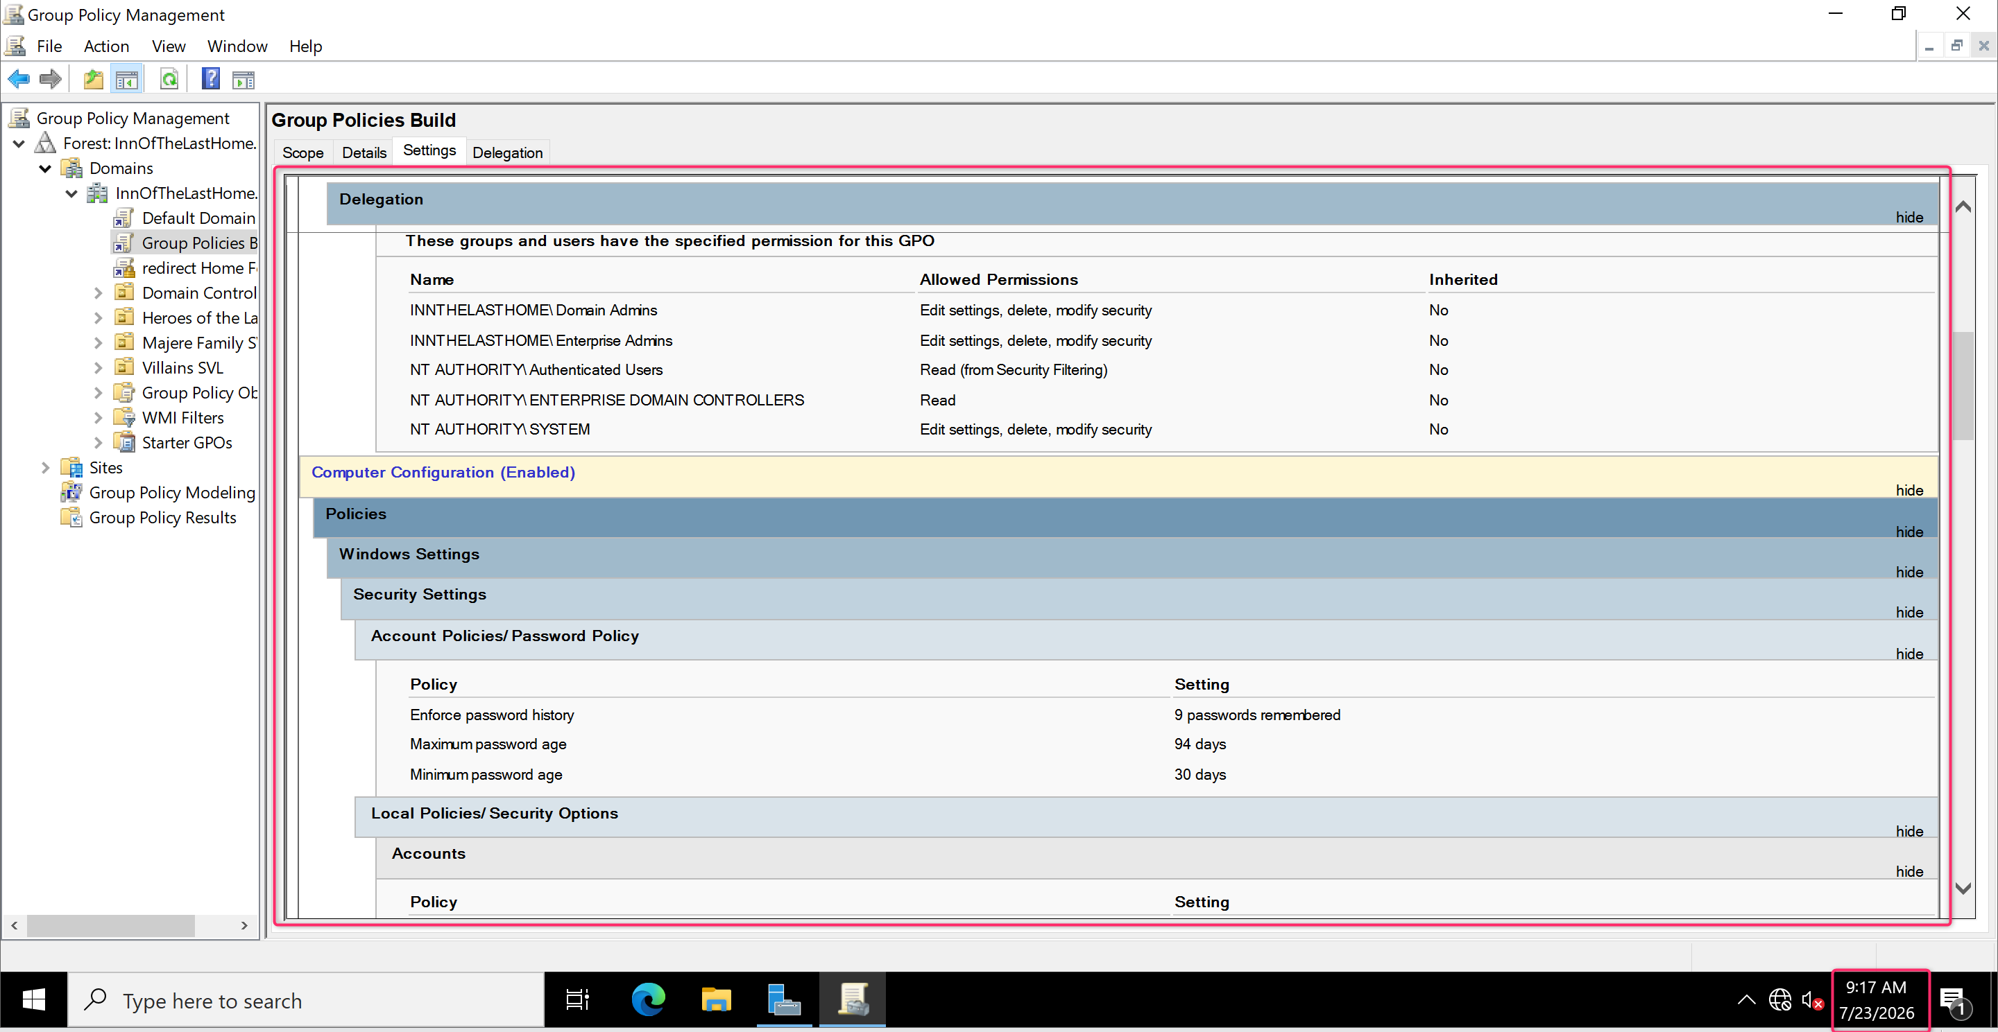
Figure 40 Group Policy Objects
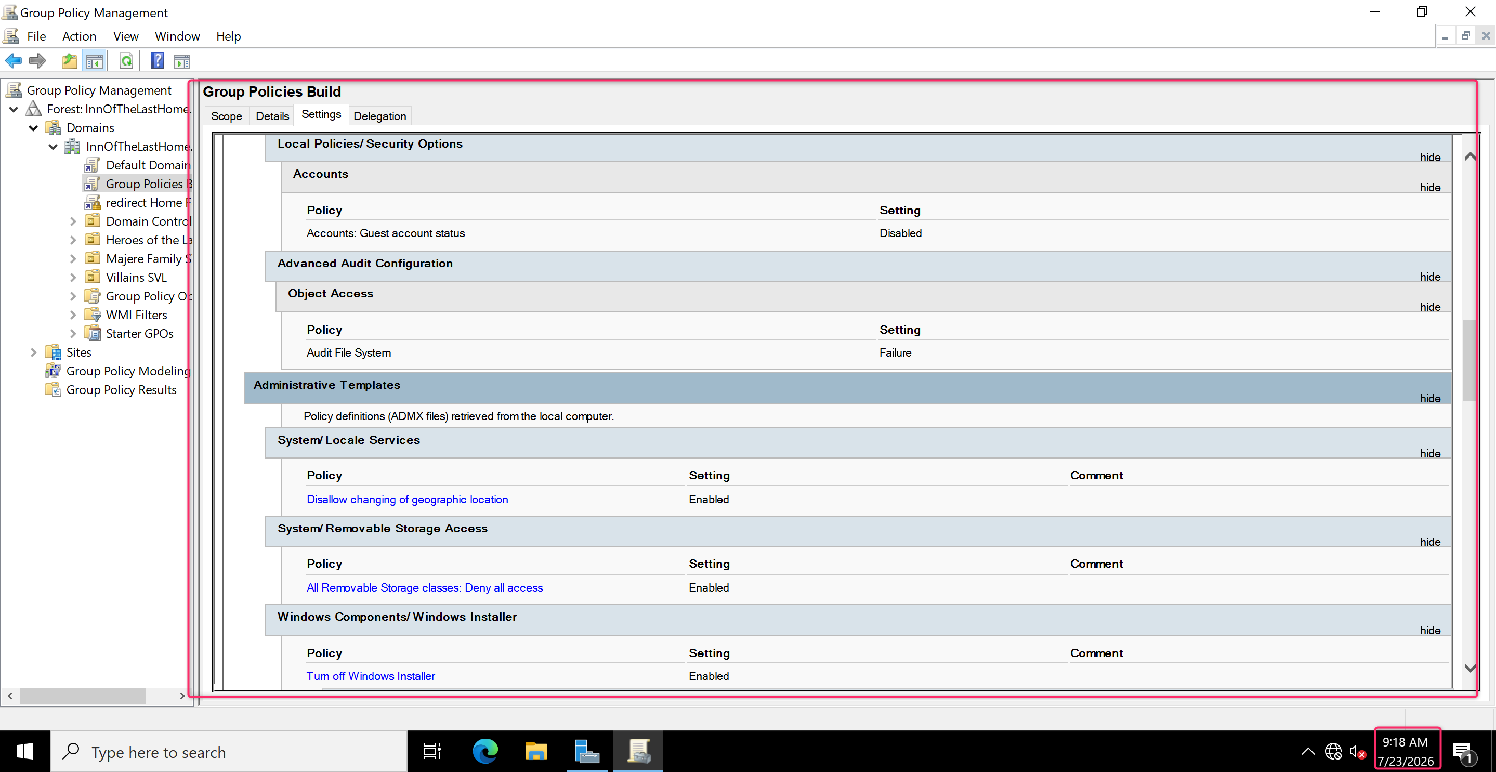
Figure 41 Group Policy Objects
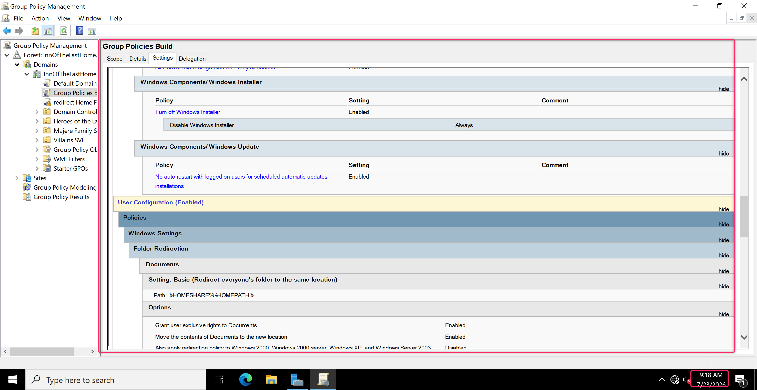
Figure 42 Group Policy Objects
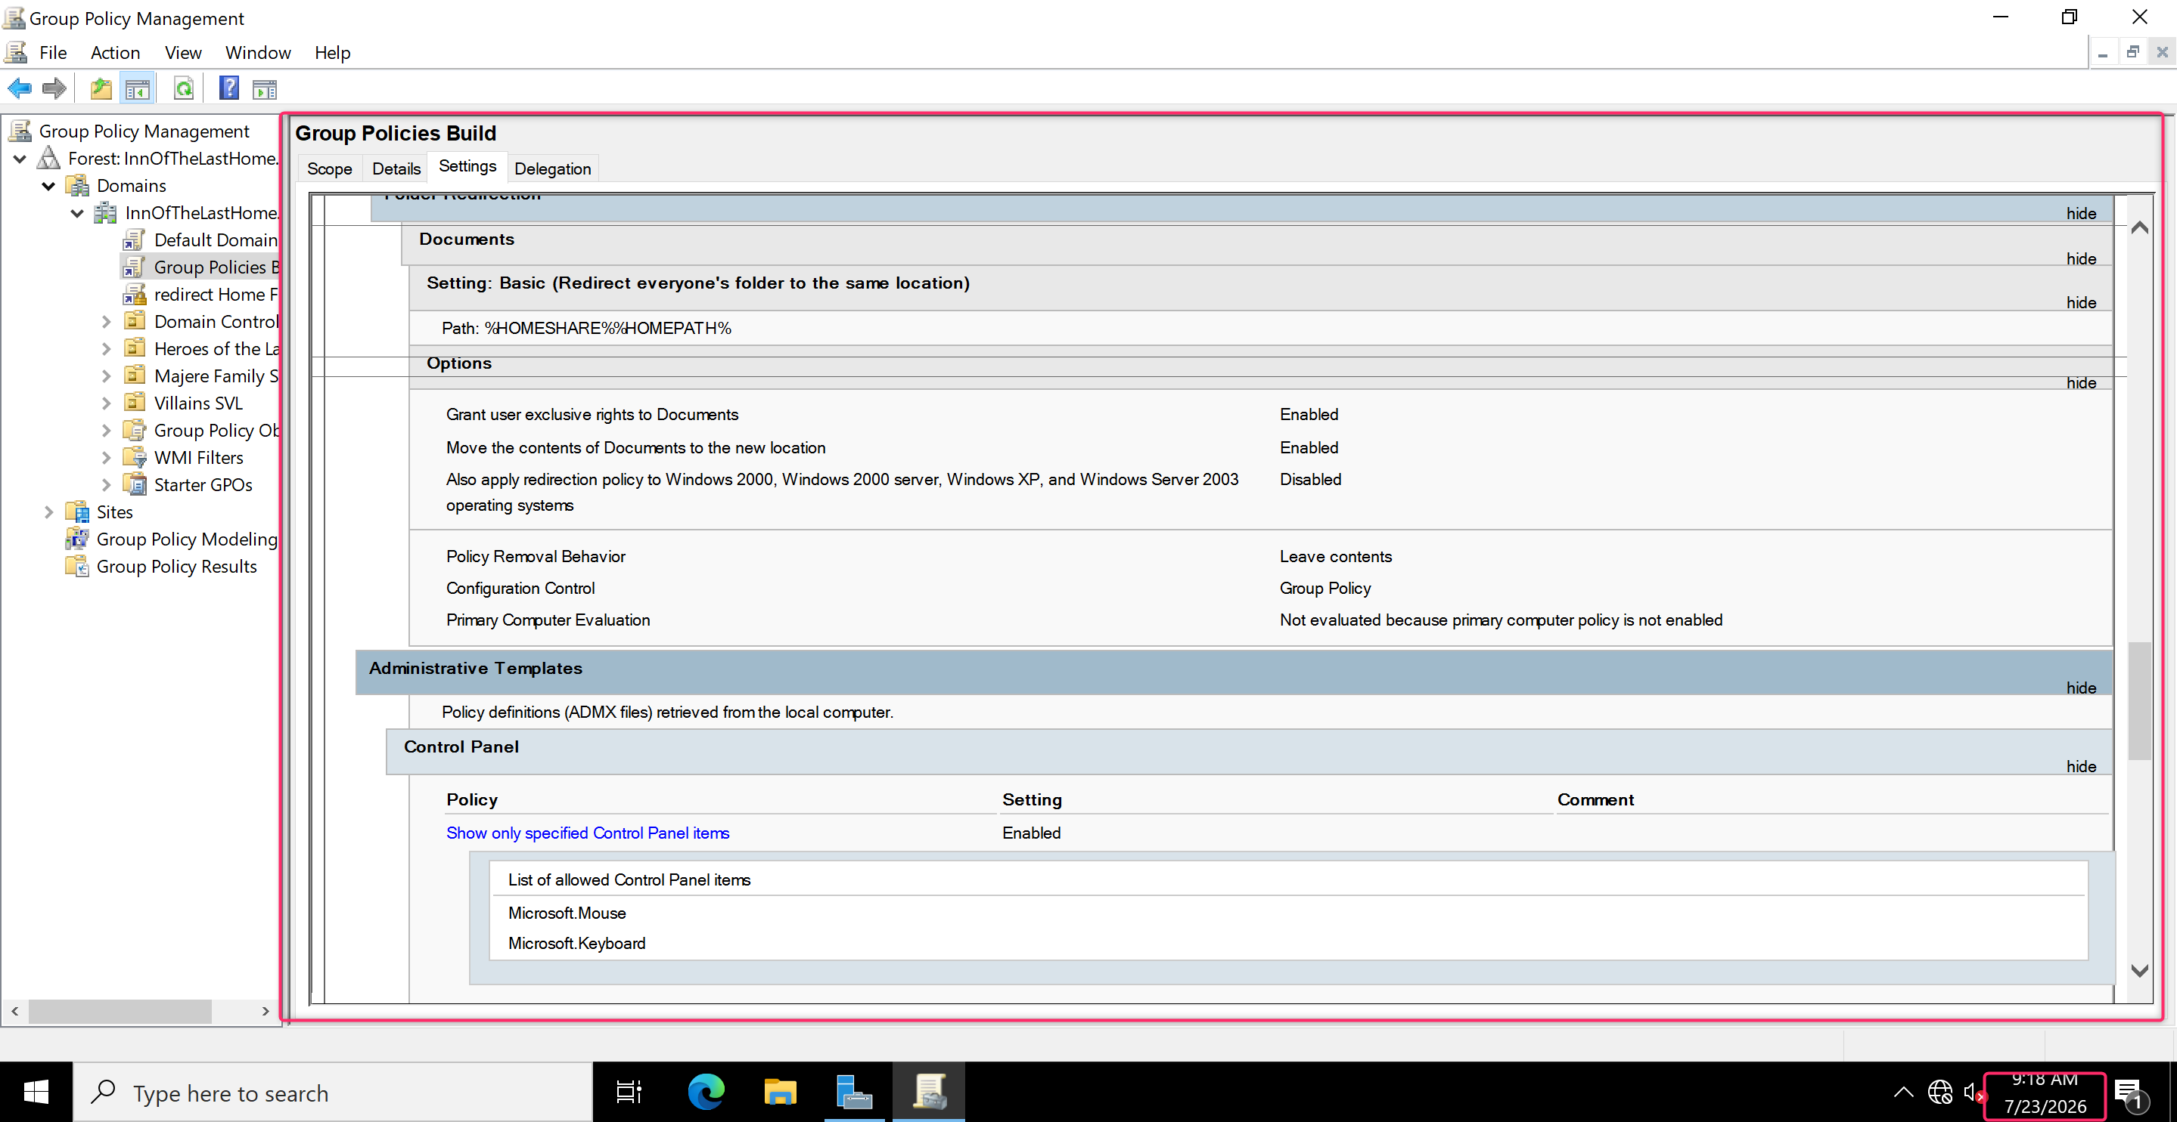
Figure 43 Group Policy Objects
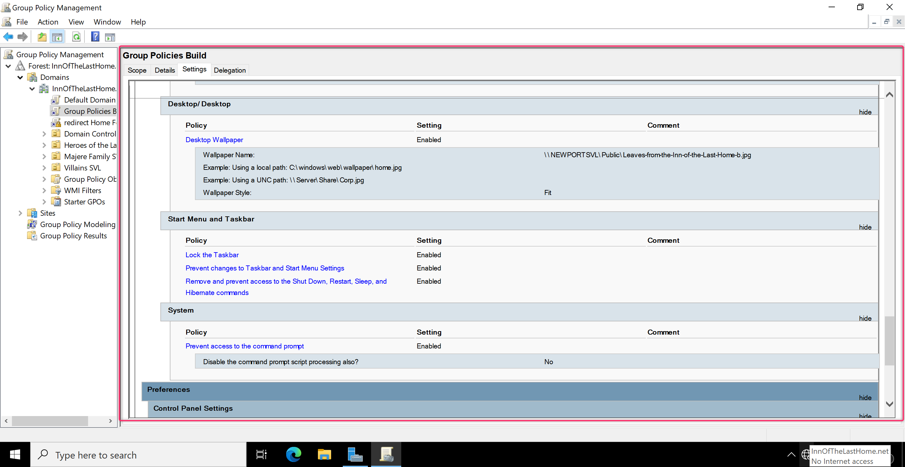
Figure 44 Group Policy Objects Settings
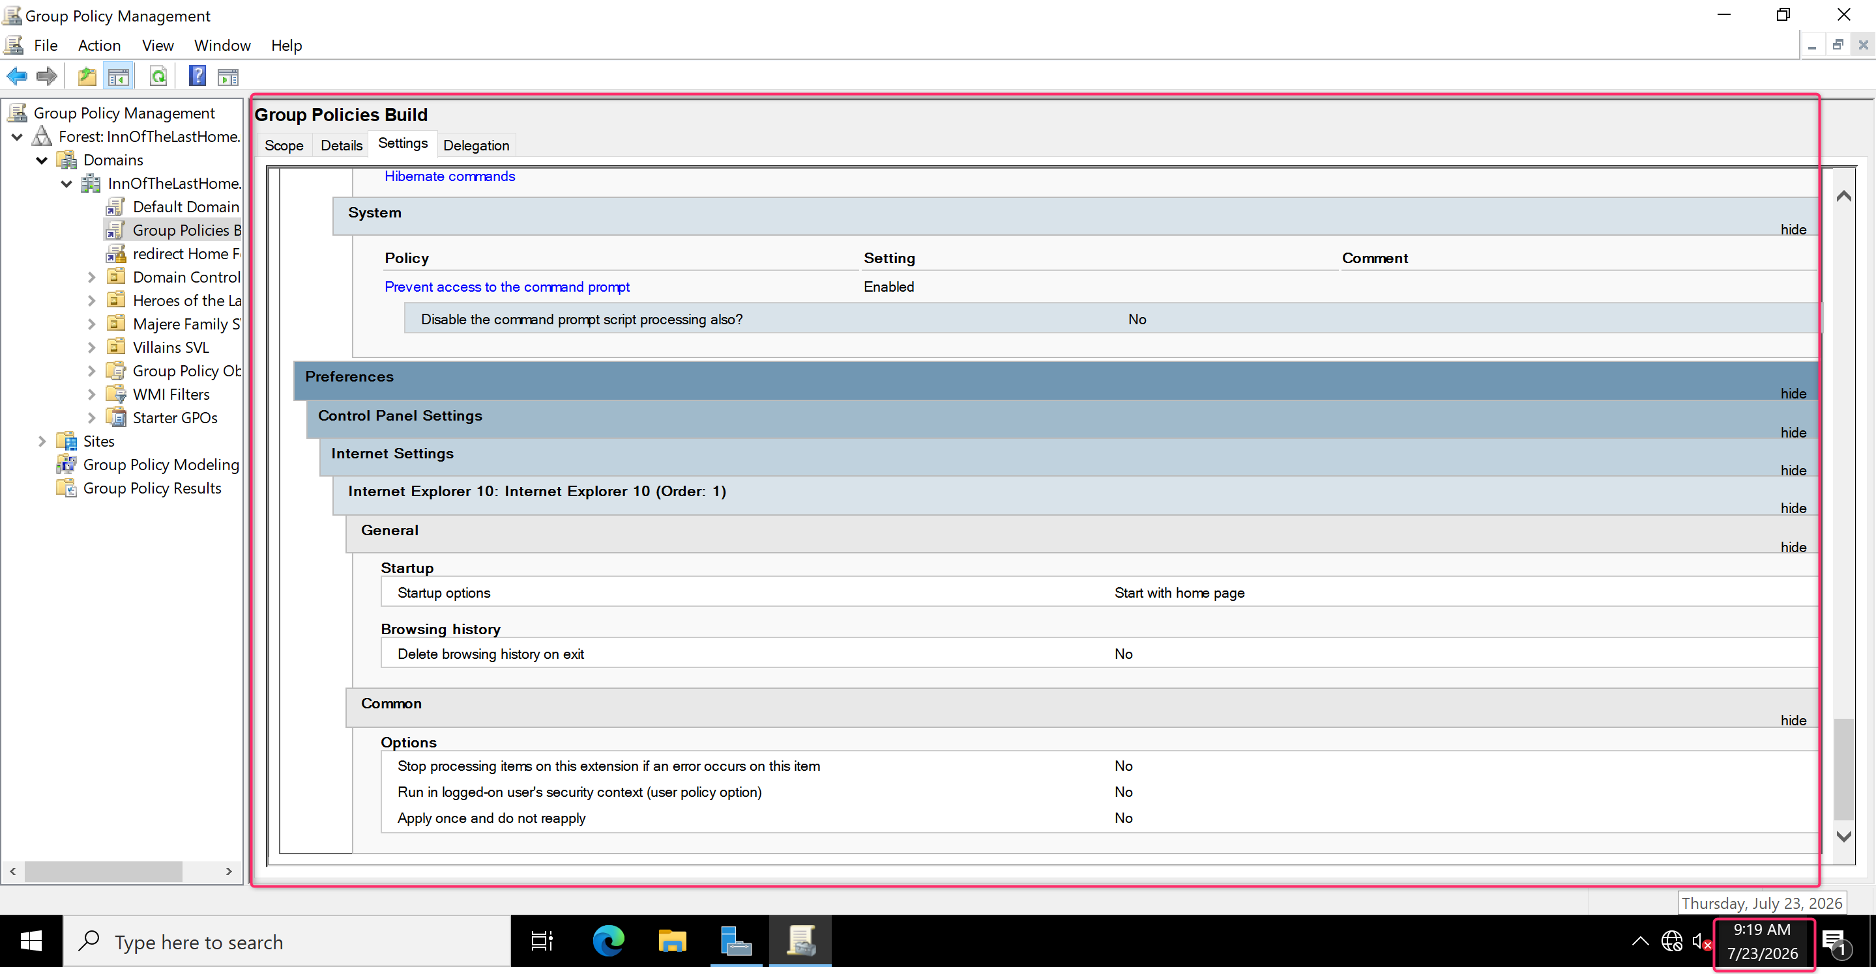
Figure 45 Group Policy Objects Settings
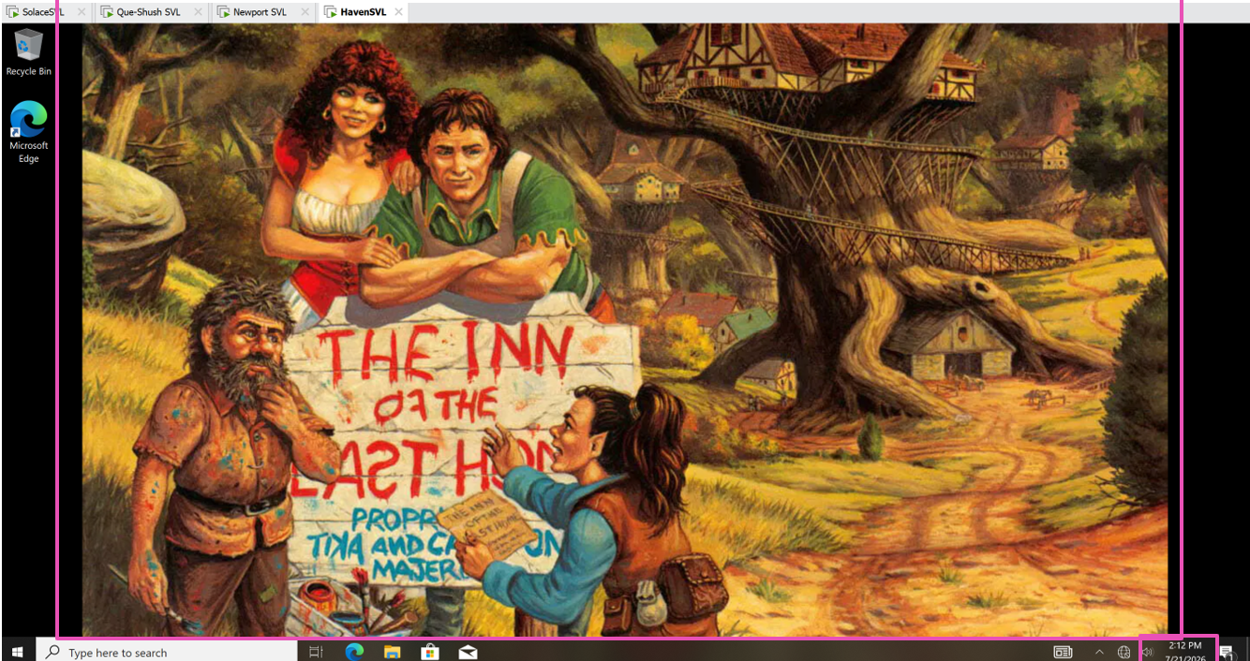
Figure 46 Testing Policies Background is changed
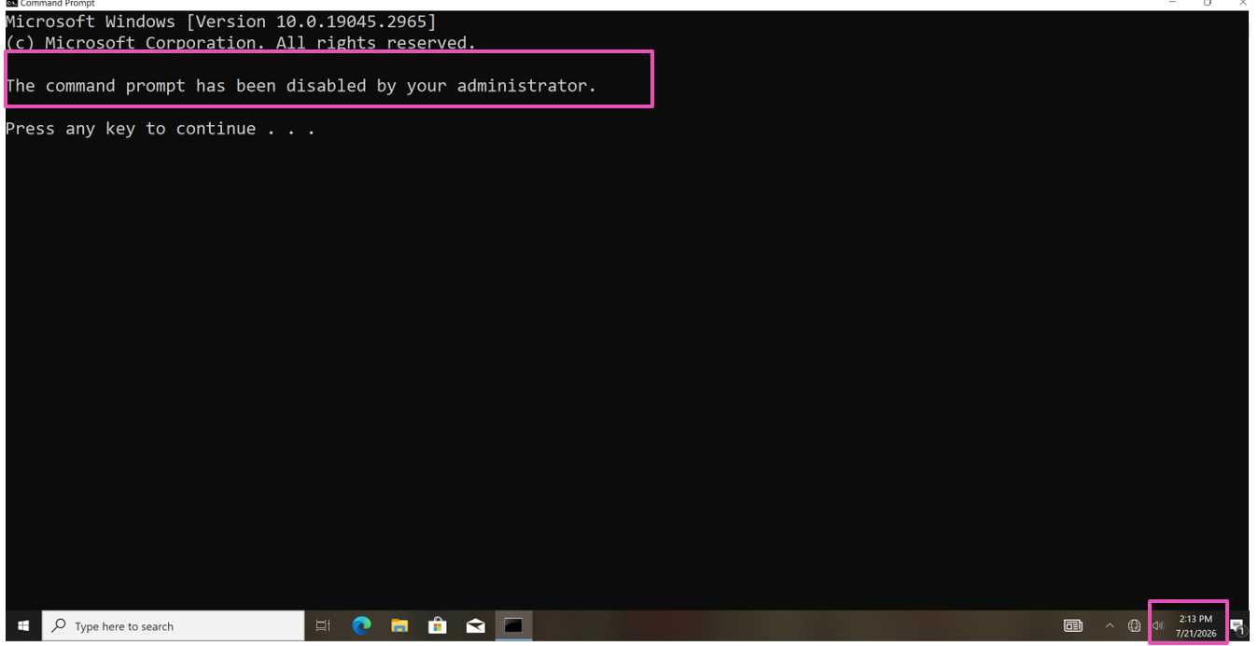
Figure 47 Testing Policies Command Prompt is disabled

Windows Admin Center
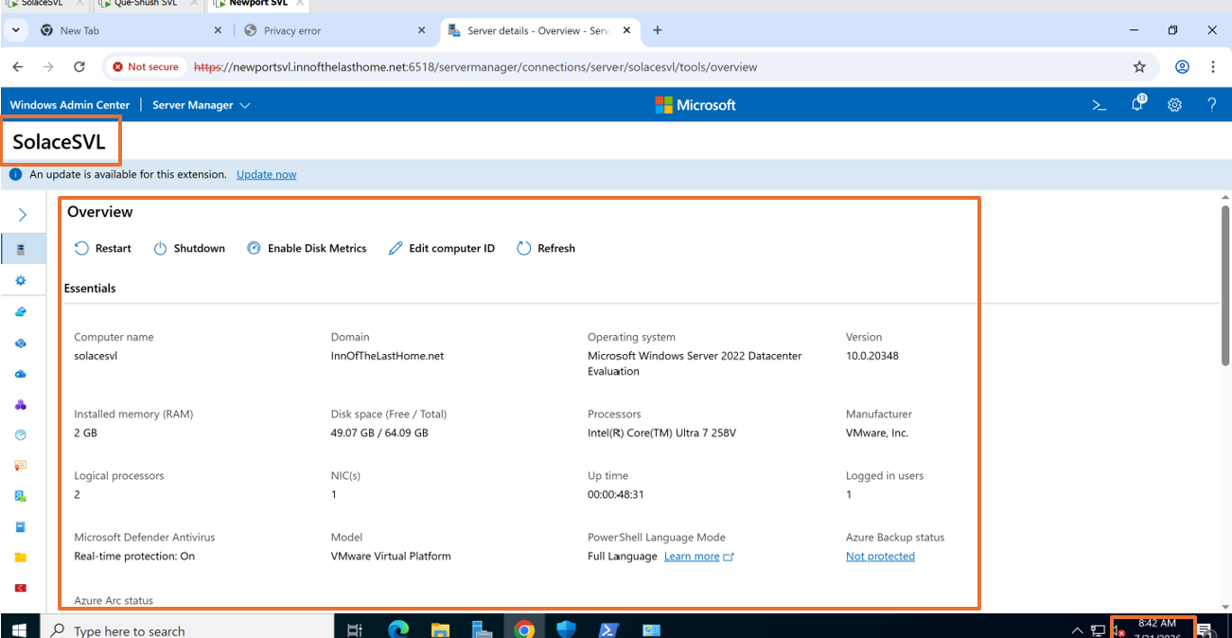
Figure 48 Server1 Dashboard Page opened in Admin Center

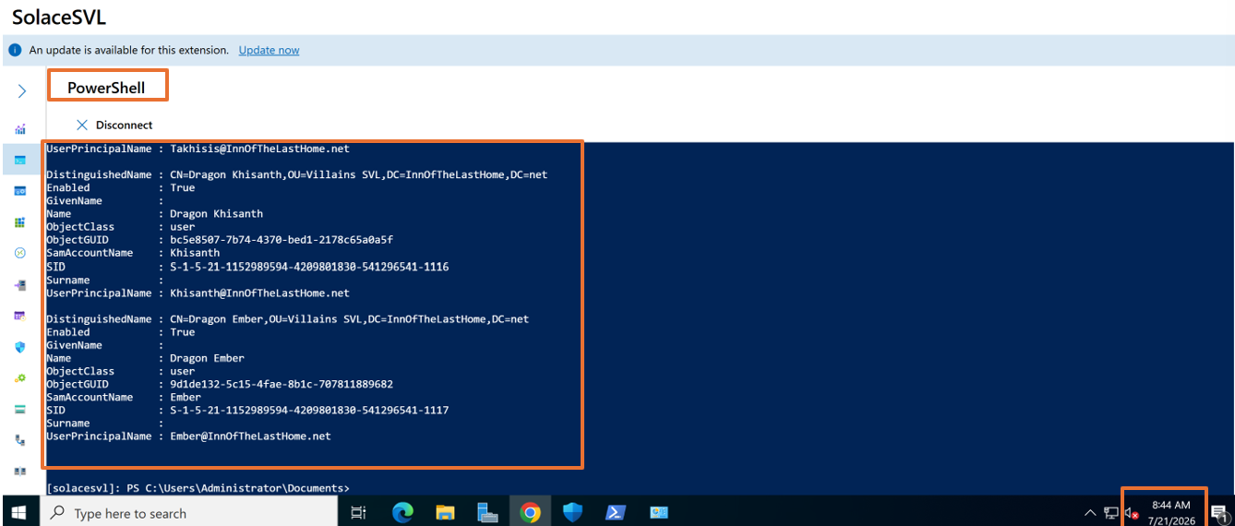
Figure 49 Powershell Command
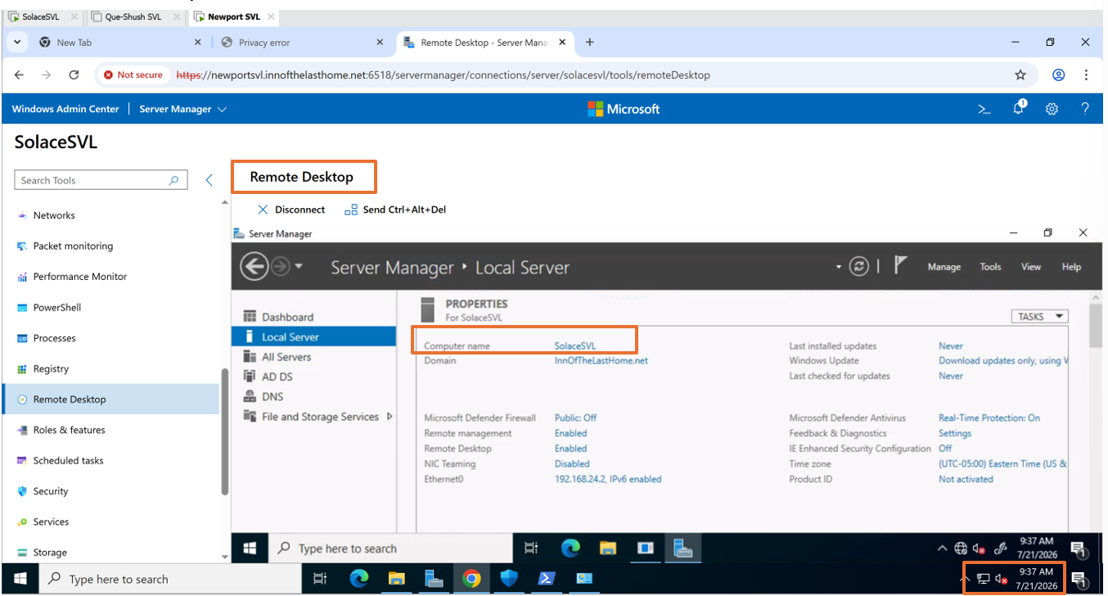
Figure 50 Remote Desktop
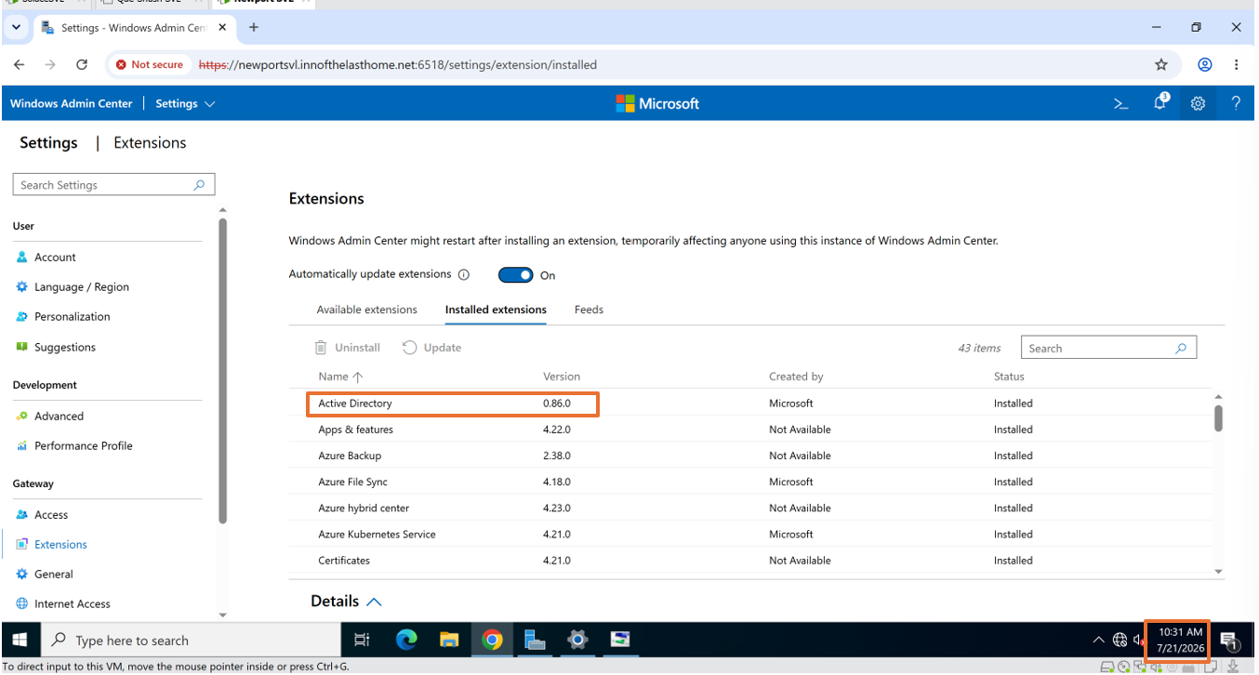
Figure 51 Installed Extension List
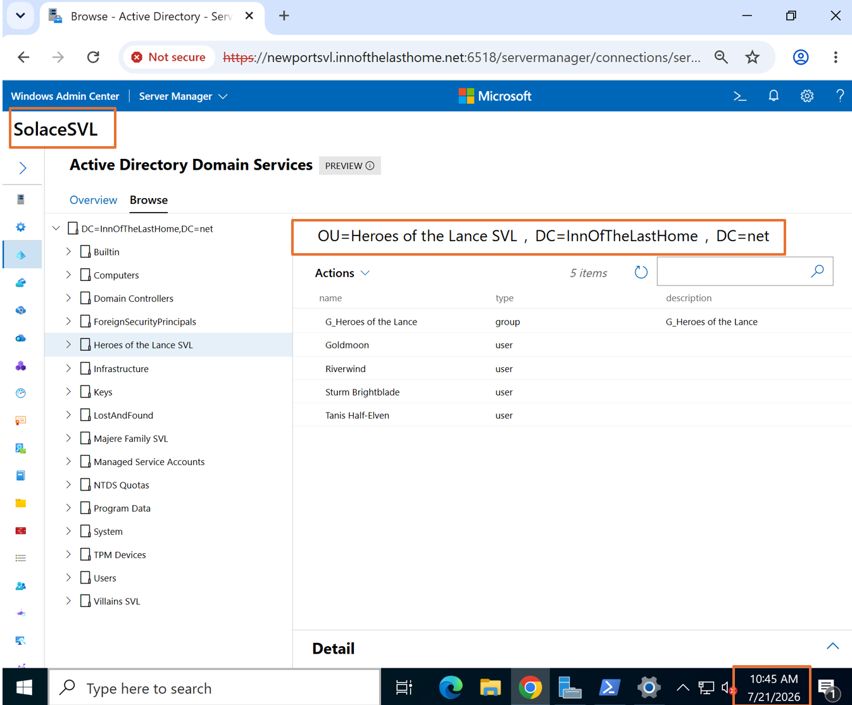
Figure 52 OU in Windows admin center
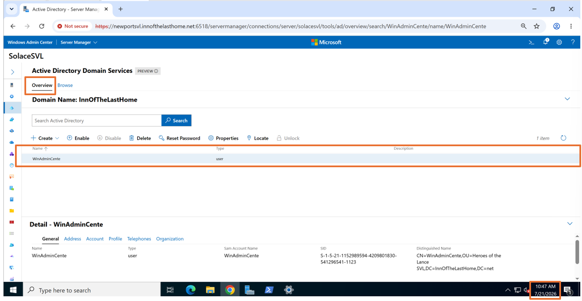
Figure 53 New user in the Overview Page

